|  |  |
| --- | --- |
| GYM Management System | Odoo Apps Store  GYM MANAGEMENT SYSTEM  A Database-Driven Project | School of Architecture, Computing & Engineering  CN5000  Database Systems  Module Leader:  Arish Siddiqui  Module Tutor:  Dhara Parekh    Group Work:  **Jasmi Preethi ALASAPURI - 2571395**  **(Group Leader)**  **Fatema DOCTOR – 2604383**  **Parth Ramchandra RATHWA - 2509367**  **Md Mahmudur RAHMAN – 2393577** |

**Submission Deadline: 18th December 2024**



Table of Contents

1. Abstract 2

2. Introduction 2

*2.1 Background* 2

*2.2 Objectives* 2

3. Entity-Relationship Diagram (ERD) 3

4. Normalized Relational Model 3

5. Use Case Diagram 5

*5.1 Use case diagram* 5

*5.2 Use Case Description* 6

6. Database Design (DDL Scripts) 7

*6.1 Data Dictionary for Gym Management System Entities:* 7

*6.2* *Creating and populating tables:* 11

7. SQL Queries and Results 30

*Query 1:* 31

*Query 2:* 31

*Query 3:* 32

*Query 4:* 33

*Query 5:* 34

*Query 6:* 35

*Query 7:* 36

*Query 8:* 37

8. Triggers and Stored Procedures 38

*Trigger 1:* 38

*Trigger 2:* 41

*Trigger 3:* 44

9. Report Reflection 46

9.1. Challenges, Key Learnings, and Improvements (CKI) 46

9.2 Group Contribution Evaluation: 47

10. Gantt Chart 47

11. Appendices 48

*PowerPoint Slides:* 48

*SQL Scripts:* 49

Additional Notes 49

# **1. Abstract**

The Gym Management System (GMS) is designed to simplify operations in a large fitness centre by managing memberships, classes, training sessions, and billing. This project focuses on creating a database system with an Entity-Relationship Diagram (ERD) and a normalized relational model to ensure efficient data management. Key features include automated processes like class booking, membership status updates, and financial tracking through SQL queries and triggers. The system aims to improve efficiency, enhance member experience, and support gym operations effectively.

# **2. Introduction**

## ***2.1 Background***

Managing gym operations like memberships, class schedules, personal training, and billing is often complex and inefficient with manual methods. GMS offers a centralized system to address these challenges, streamlining processes and improving customer experience. This case study focuses on creating a robust database to handle core gym functions like tracking attendance, managing bookings, and monitoring progress, ensuring accurate and reliable operations.

## ***2.2 Objectives***

1. **Design and Implement a Database**
   * Build a relational database to manage gym operations efficiently.
2. **Provide ERD and Normalized Models**
   * Create an ERD to visualize relationships and normalize data to eliminate redundancy.
3. **Develop SQL Queries and Triggers**
   * Write queries for key operations like revenue tracking and class bookings.
   * Use triggers to automate tasks like updating membership status and managing class capacities.

This project ensures a well-organized system to enhance gym efficiency and member satisfaction.

# **3. Entity-Relationship Diagram (ERD)**

The first ERD has 17 entities. The diagram has entities whose values are in atomic form, each entity has a primary key and there are no repeating values in a row, hence it is in 1NF.

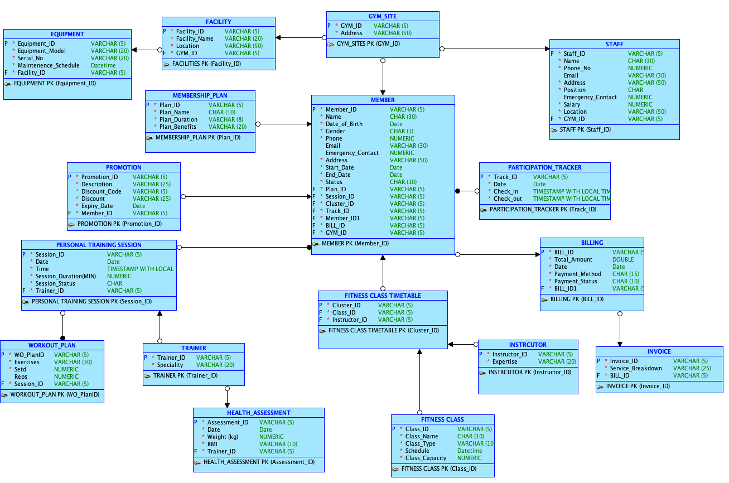

*Fig 3.1: Denormalized logical ERD*

# **4. Normalized Relational Model**

* This version of the ERD is more refined as ‘MEMBER’ entity addresses the duplication by linking to related tables, avoiding storing redundant membership details.
* There are no partial dependencies in the ERD as well have been removed by creating a ‘BOOKING SYSTEM’ entity where all the class and session details have been integrated properly.
* Weak entities like ‘EQUIPMENT’, ‘GYM_SITE’ and ‘INVOICE’ have been removed, and entities like ‘TRAINER’ and ‘INSTRUCTOR’ have been integrated into the ‘STAFF’ entity.
* Here all non-key attributes are directly dependant only on the primary key, making it a 3NF entity relationship diagram.

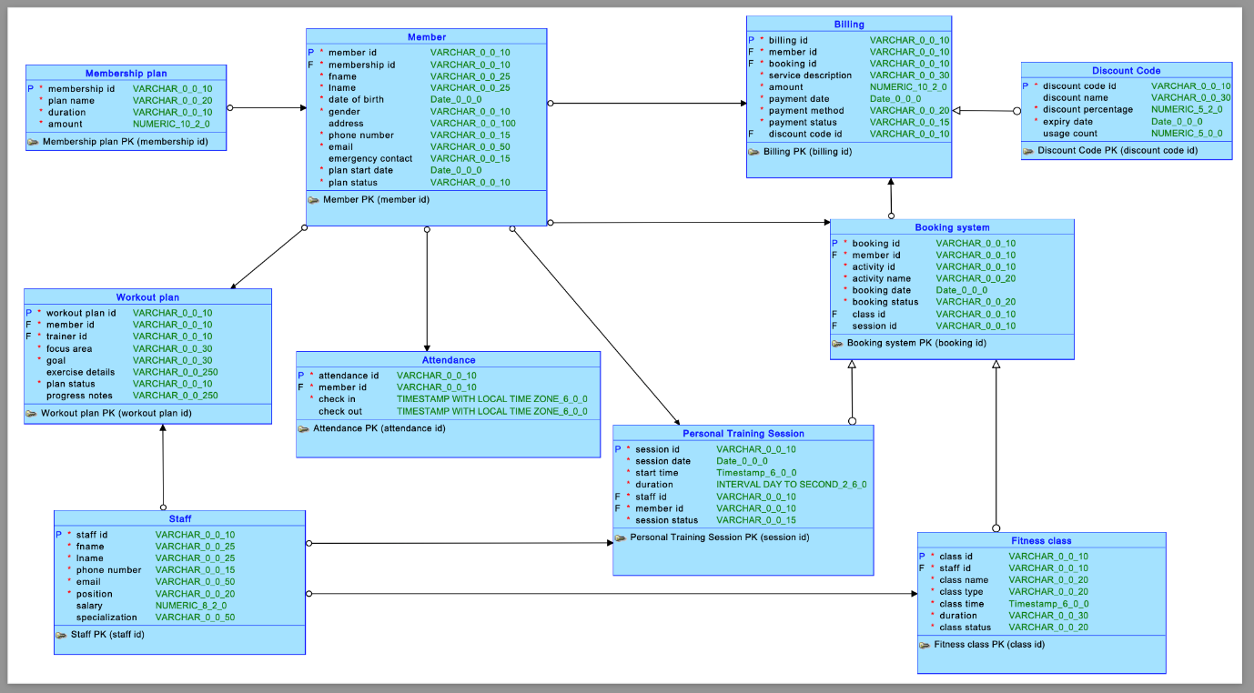

*Fig 4.1: Normalized logical ERD*

* Mapped the logical model to a relational model after normalization.******

*Fig 4.1: Fully normalized relational ERD*

# **5. Use Case**

## *5.1 Use case diagram*

* Use Case Diagram showing key actors (e.g., Members, Staff, Admin) and system interactions.

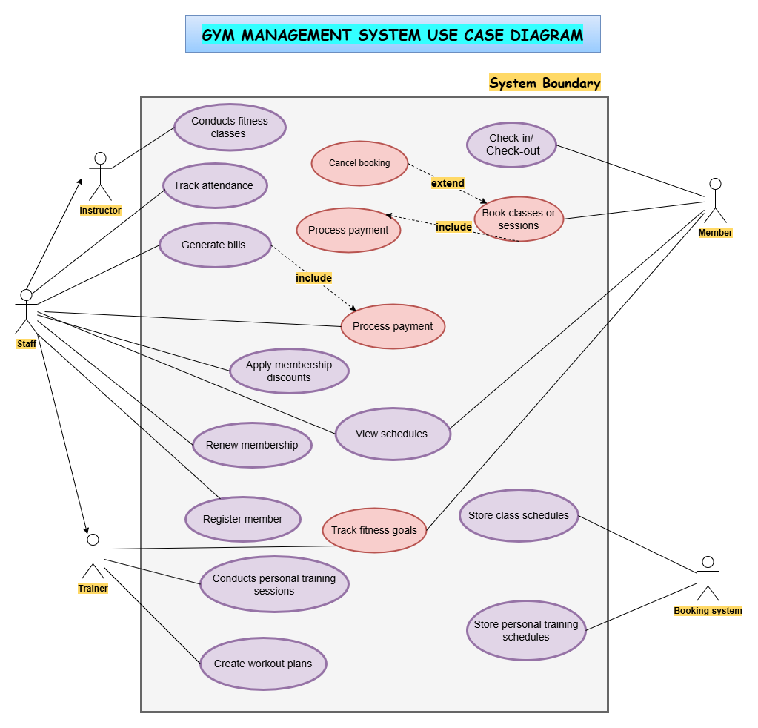

*Fig 5.1: Use Case Diagram*

## *5.2 Use Case Description*

|  |  |
| --- | --- |
| Use Case | Book Classes or Sessions |
| Description | Allows members to book fitness classes or personal training sessions. |
| Actor(s) | Member, Booking System |
| Pre-conditions | - Member is registered in the system.  - Booking schedules are available. |
| Steps | 1. The member views available classes or sessions.  2. The system checks availability.  3. The member books the class/session.  4. The system processes payment (if applicable).  5. Confirmation is provided. |
| Extensions | - **Cancel Booking**: A member may cancel a previously booked session. |
| Exceptions | - Insufficient slots or schedule conflicts.  - Payment failure. |

*Table 5.1 Use Case Description to book classes or sessions*

|  |  |
| --- | --- |
| Use Case | Process Payment |
| Description | Manages payment processing for memberships, class bookings, or services. |
| Actor(s) | Member, Staff |
| Pre-conditions | - Member has initiated a payment transaction. |
| Steps | 1. The system calculates the total payment.  2. Member or staff inputs payment details.  3. The system verifies payment details.  4. Payment is processed and confirmed. |
| Inclusions | - Included in **Book Classes or Sessions**. |
| Exceptions | - Invalid payment details.  - Payment gateway errors. |

*Table 5.2 Use Case Description to process payment*

|  |  |
| --- | --- |
| Use Case | Track Fitness Goals |
| Description | Allows members to set and monitor their fitness goals over time. |
| Actor(s) | Member |
| Pre-conditions | - Member is registered and logged in. |
| Steps | 1. The member sets fitness goals.  2. The system stores the goals.  3. Progress is displayed periodically. |
| Exceptions | - Goals cannot be saved due to system error. |

*Table 5.3 Use Case Description to track fitness goals*

|  |  |
| --- | --- |
| Use Case | Conduct Fitness Classes |
| Description | The instructor conducts scheduled fitness classes for members. |
| Actor(s) | Instructor |
| Pre-conditions | - The class has been scheduled.  - Members have booked the class. |
| Steps | 1. The instructor accesses the class schedule.  2. The instructor conducts the class.  3. Attendance is tracked. |
| Post-conditions | - Attendance records are updated. |

*Table 5.4 Use Case Description to conduct fitness classes*

|  |  |
| --- | --- |
| Use Case | Store Class Schedules |
| Description | Maintains and updates the list of scheduled fitness classes. |
| Actor(s) | Booking System |
| Steps | 1. The system stores fitness class schedules.  2. Updates are made when needed. |

*Table 5.5 Use Case Description to store class schedules*

# **6. Database Design (DDL Scripts)**

## *6.1 Data Dictionary for Gym Management System Entities:*

|  |  |  |  |  |
| --- | --- | --- | --- | --- |
| 1. 1. MEMBER | | | | |
| Field Name | **Data Type** | **Description** | **Constraints** | **Example Value** |
| Member_id | VARCHAR2(10) | Unique ID for each member. | Primary Key | MEM001 |
| Membership_id | VARCHAR2(10) | ID of the member's membership plan. | Foreign Key (Membership_Plan), Not Null | PLAN001 |
| Fname | VARCHAR2(25) | Member's first name. | Not Null | John |
| Lname | VARCHAR2(25) | Member's last name. | Not Null | Doe |
| Date_of_birth | DATE | Member's date of birth. | Not Null | 15/01/1990 |
| Gender | VARCHAR2(10) | Member's gender. | Not Null | Male |
| Address | VARCHAR2(30) | Member's residential address. | Nullable | 123 Main St |
| Phone_number | VARCHAR2(15) | Member's contact number. | Not Null | 9876543210 |
| Email | VARCHAR2(50) | Member's email address. | Not Null, Unique | john.doe@gmail.com |
| Emergency_contact | VARCHAR2(15) | Contact number in case of emergency. | Nullable | 9876543211 |
| Plan_start_date | DATE | Start date of the member's plan. | Not Null | 01/12/2023 |
| Plan_status | VARCHAR2(10) | Current status of the member's plan. | Not Null | Active |

*Table 6.1 Data dictionary: Member*

|  |  |  |  |  |
| --- | --- | --- | --- | --- |
| 2. STAFF | | | | |
| Field Name | **Data Type** | **Description** | **Constraints** | **Example Value** |
| Staff_id | VARCHAR2(10) | Unique ID for each staff member. | Primary Key | STF001 |
| Fname | VARCHAR2(25) | Staff member's first name. | Not Null | Alice |
| Lname | VARCHAR2(25) | Staff member's last name. | Not Null | Smith |
| Phone_number | VARCHAR2(15) | Staff member's contact number. | Not Null | 9876543212 |
| Email | VARCHAR2(50) | Staff member's email address. | Not Null | alice@gmail.com |
| Position | VARCHAR2(20) | Job position of the staff member. | Not Null | Trainer |
| Salary | NUMBER(8,2) | Staff member's salary. | Not Null | 45000 |
| Specialization | VARCHAR2(50) | Staff member's area of expertise. | Nullable | Yoga |

*Table 6.2 Data dictionary: Staff*

|  |  |  |  |  |
| --- | --- | --- | --- | --- |
| 3. BOOKING SYSTEM | | | | |
| Field Name | **Data Type** | **Description** | **Constraints** | **Example Value** |
| Booking_id | VARCHAR2(10) | Unique ID for each booking. | Primary Key | BOOK001 |
| Member_id | VARCHAR2(10) | ID of the member making the booking. | Foreign Key (Member) | MEM001 |
| Class_id | VARCHAR2(10) | ID of the fitness class booked. | Foreign Key (Fitness_Class), Null | CLS001 |
| Session_id | VARCHAR2(10) | ID of the personal training session booked. | Foreign Key (Personal_Training_Session), Null | SES001 |
| Activity_name | VARCHAR2(20) | Name of the activity booked. | Not Null | Yoga |
| Booking_date | DATE | Date the booking was made. | Not Null | 02/12/2023 |
| Booking_status | VARCHAR2(20) | Status of the booking. | Not Null | Confirmed |

*Table 6.3 Data dictionary: Booking system*

|  |  |  |  |  |
| --- | --- | --- | --- | --- |
| 4. FITNESS CLASS | | | | |
| Field Name | **Data Type** | **Description** | **Constraints** | **Example Value** |
| Class_id | VARCHAR2(10) | Unique ID for each class. | Primary Key | CLS001 |
| Staff_id | VARCHAR2(10) | ID of the staff conducting the class. | Foreign Key (Staff), Not Null | STF001 |
| Class_name | VARCHAR2(20) | Name of the fitness class. | Not Null | Pilates |
| Class_type | VARCHAR2(20) | Type of fitness class (e.g., Cardio, Yoga). | Not Null | Yoga |
| Class_time | TIMESTAMP | Scheduled date and time of the class. | Not Null | 03/12/2023 10:00 |
| Duration | VARCHAR2(30) | Duration of the class. | Not Null | 1 Hour |
| Max_capacity | NUMBER(3,0) | Maximum capacity of the class. | Not Null | 20 |
| Class_status | VARCHAR2(20) | Status of the class (e.g., Scheduled, Cancelled) | Not Null | Scheduled |

*Table 6.4 Data dictionary: Fitness Class*

|  |  |  |  |  |
| --- | --- | --- | --- | --- |
| 5. PERSONAL TRAINING SESSION | | | | |
| Field Name | **Data Type** | **Description** | **Constraints** | **Example Value** |
| session_id | VARCHAR2(10) | Unique identifier for the session. | PRIMARY KEY, NOT NULL | S001 |
| session_date | DATE | The date the personal training session took place. | NOT NULL | 03/12/2024 |
| start_time | TIMESTAMP | The start time of the session. | NOT NULL | 03/12/2024 10:00 |
| duration | VARCHAR2(30) | Duration of the session (e.g., 1 hour, 45 mins). | NOT NULL | 1 hour |
| staff_id | VARCHAR2(10) | Unique identifier for the staff member conducting the session. | NOT NULL | ST001 |
| member_id | VARCHAR2(10) | Unique identifier for the member attending the session. | NOT NULL | M001 |
| session_status | VARCHAR2(15) | Status of the session (e.g., Completed, Pending). | NOT NULL | Completed |

*Table 6.5 Data dictionary: Personal training session*

|  |  |  |  |  |
| --- | --- | --- | --- | --- |
| 6. WORKOUT PLAN | | | | |
| Field Name | **Data Type** | **Description** | **Constraints** | **Example Value** |
| workout_plan_id | VARCHAR2(10) | Unique identifier for the workout plan. | PRIMARY KEY, NOT NULL | WP001 |
| member_id | VARCHAR2(10) | Unique identifier for the member the workout plan is created for. | NOT NULL | M001 |
| trainer_id | VARCHAR2(10) | Unique identifier for the trainer who created the plan. | NOT NULL | T001 |
| focus_area | VARCHAR2(30) | The area the workout plan focuses on (e.g., Strength, Cardio). | NOT NULL | Strength |
| goal | VARCHAR2(30) | The goal of the workout plan (e.g., Muscle Gain, Weight Loss). | NOT NULL | Muscle Gain |
| exercise_details | VARCHAR2(250) | Details of the exercises included in the workout plan. | NULL | Squats, Bench Press, Deadlift |
| plan_status | VARCHAR2(10) | Status of the workout plan (e.g., Active, Inactive). | NOT NULL | Active |
| progress_notes | VARCHAR2(250) | Notes on the member's progress in the plan. | Nullable |  |

*Table 6.6 Data dictionary: Workout plan*

|  |  |  |  |  |
| --- | --- | --- | --- | --- |
| 7. MEMBERSHIP PLAN | | | | |
| Field Name | **Data Type** | **Description** | **Constraints** | **Example Value** |
| membership_id | VARCHAR2(10) | Unique identifier for the membership plan. | PRIMARY KEY, NOT NULL | MP001 |
| plan_name | VARCHAR2(20) | The name of the membership plan (e.g., Basic, Premium). | NOT NULL | Basic |
| duration | VARCHAR2(10) | The duration of the membership (e.g., 1 Month, 12 Months). | NOT NULL | 1 Month |
| amount | NUMBER (10,2) | The cost of the membership plan. | NOT NULL | 30 |

*Table 6.7 Data dictionary: Membership plan*

|  |  |  |  |  |
| --- | --- | --- | --- | --- |
| 8. DISCOUNT CODE | | | | |
| Field Name | **Data Type** | **Description** | **Constraints** | **Example Value** |
| Discount_Code_ID | VARCHAR2(10) | Unique identifier for the discount code. | PRIMARY KEY, NOT NULL | D001 |
| Discount_Name | VARCHAR2(30) | The name of the discount (e.g., Summer Sale, Black Friday). | NULL | Summer Sale |
| Discount_Percentage | NUMBER (5,2) | The percentage discount (e.g., 15.00 for 15%). | NOT NULL | 15 |
| Expiry_Date | DATE | The expiry date of the discount code. | NOT NULL | 31/12/2024 |
| Usage_Count | NUMBER (5) | The number of times the discount code has been used. | NULL | 50 |

*Table 6.8 Data dictionary: Discount code*

|  |  |  |  |  |
| --- | --- | --- | --- | --- |
| 9. BILLING | | | | |
| Field Name | **Data Type** | **Description** | **Constraints** | **Example Value** |
| billing_id | VARCHAR2(10) | Unique identifier for the billing record. | PRIMARY KEY, NOT NULL | B001 |
| member_id | VARCHAR2(10) | Unique identifier for the member being billed. | NOT NULL | M001 |
| Discount_Code_ID | VARCHAR2(10) | Identifier for any discount code applied to the billing. | NOT NULL | D001 |
| service_description | VARCHAR2(30) | Description of the service being billed (e.g., Gym Membership). | NOT NULL | Gym Membership |
| amount | NUMBER(10,2) | The total amount to be paid for the service. | NOT NULL | 30 |
| payment_date | DATE | The date the payment was made. | NOT NULL | 03/12/2024 |
| payment_method | VARCHAR2(20) | The method used to make the payment (e.g., Credit Card). | NOT NULL | Credit Card |
| payment_status | VARCHAR2(15) | Status of the payment (e.g., Paid, Pending). | NOT NULL | Paid |

*Table 6.9 Data dictionary: Billing*

|  |  |  |  |  |
| --- | --- | --- | --- | --- |
| 10. ATTENDANCE | | | | |
| Field Name | **Data Type** | **Description** | **Constraints** | **Example Value** |
| attendance_id | VARCHAR2(10) | Unique identifier for the attendance record. | PRIMARY KEY, NOT NULL | A001 |
| member_id | VARCHAR2(10) | Unique identifier for the member attending the facility. | NOT NULL | M001 |
| check_in | TIMESTAMP WITH LOCAL TIME ZONE | The time when the member checked in. | NOT NULL | 2024-12-03 10:00:00+00 |
| check_out | TIMESTAMP WITH LOCAL TIME ZONE | The time when the member checked out. If null, member has not yet checked out. | NULL | 2024-12-03 11:00:00+00 |

*Table 6.10 Data dictionary: Attendance*

## *6.2 Creating and populating tables:*

1. 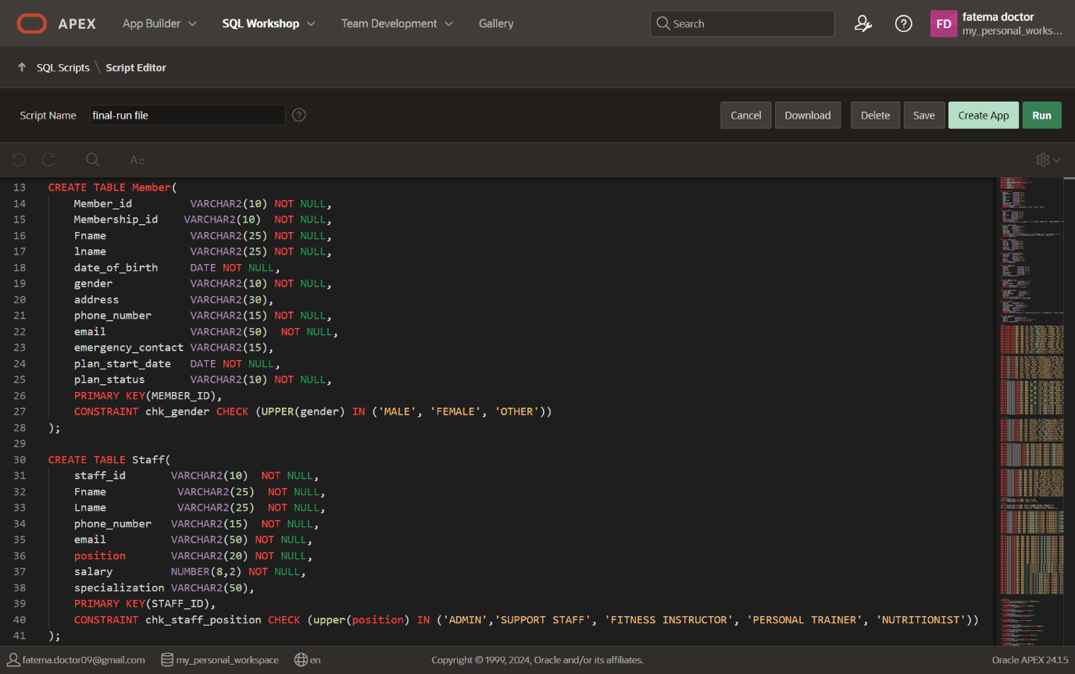**Member**

*Fig. 6.1: Creating* ***‘MEMBER’*** *table*

*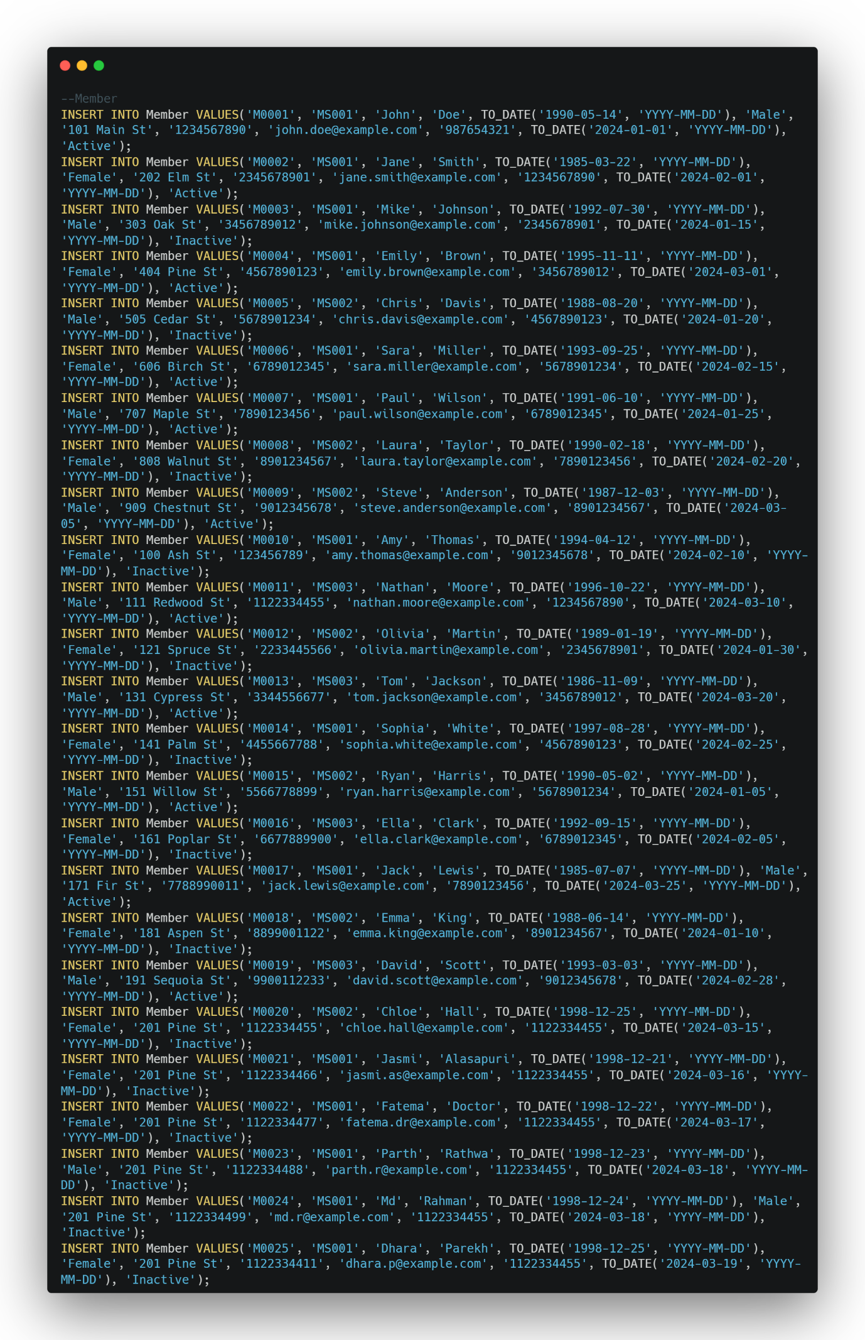 Fig 6.2: Populating* ***‘MEMBER’*** *table*

*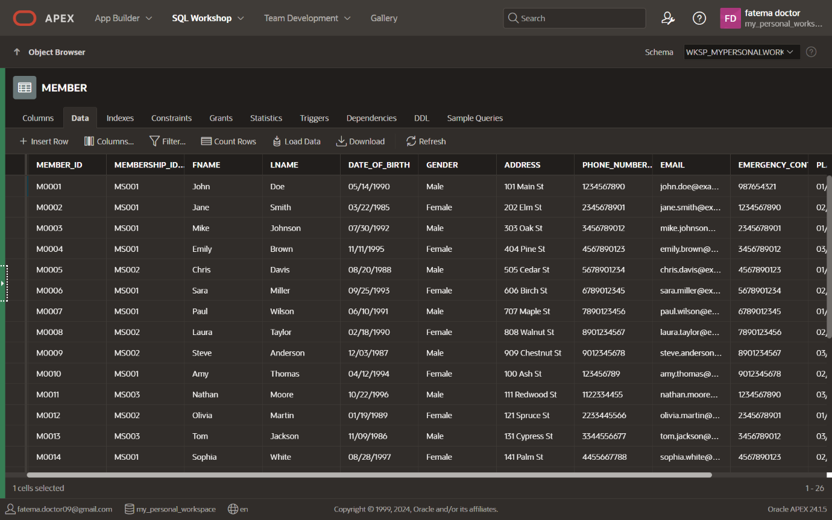 Fig. 6.3:* ***‘MEMBER’*** *table*

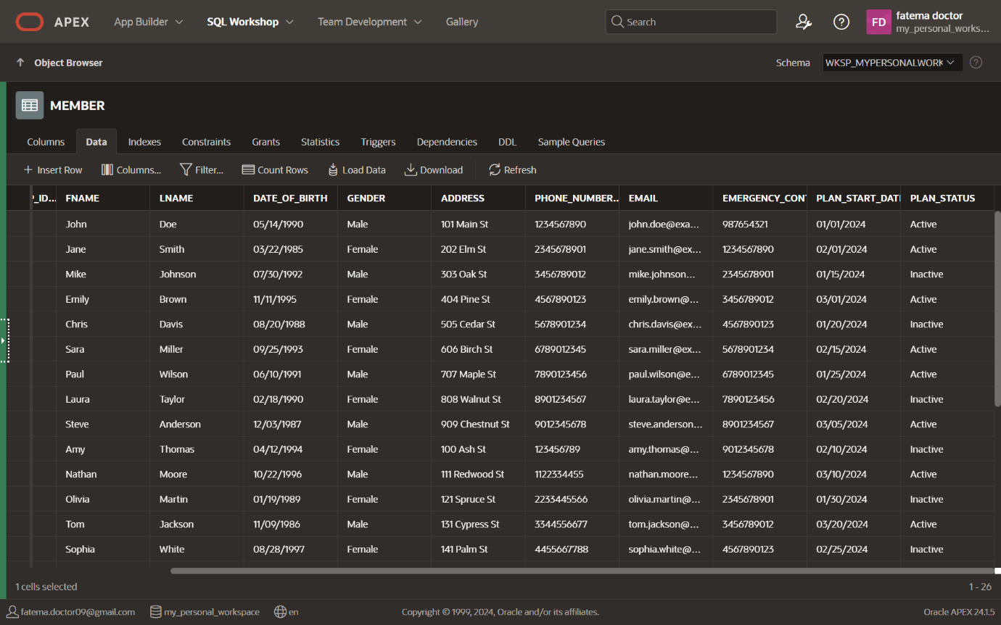 *Fig. 6.4:* ***‘MEMBER’*** *table*

1. 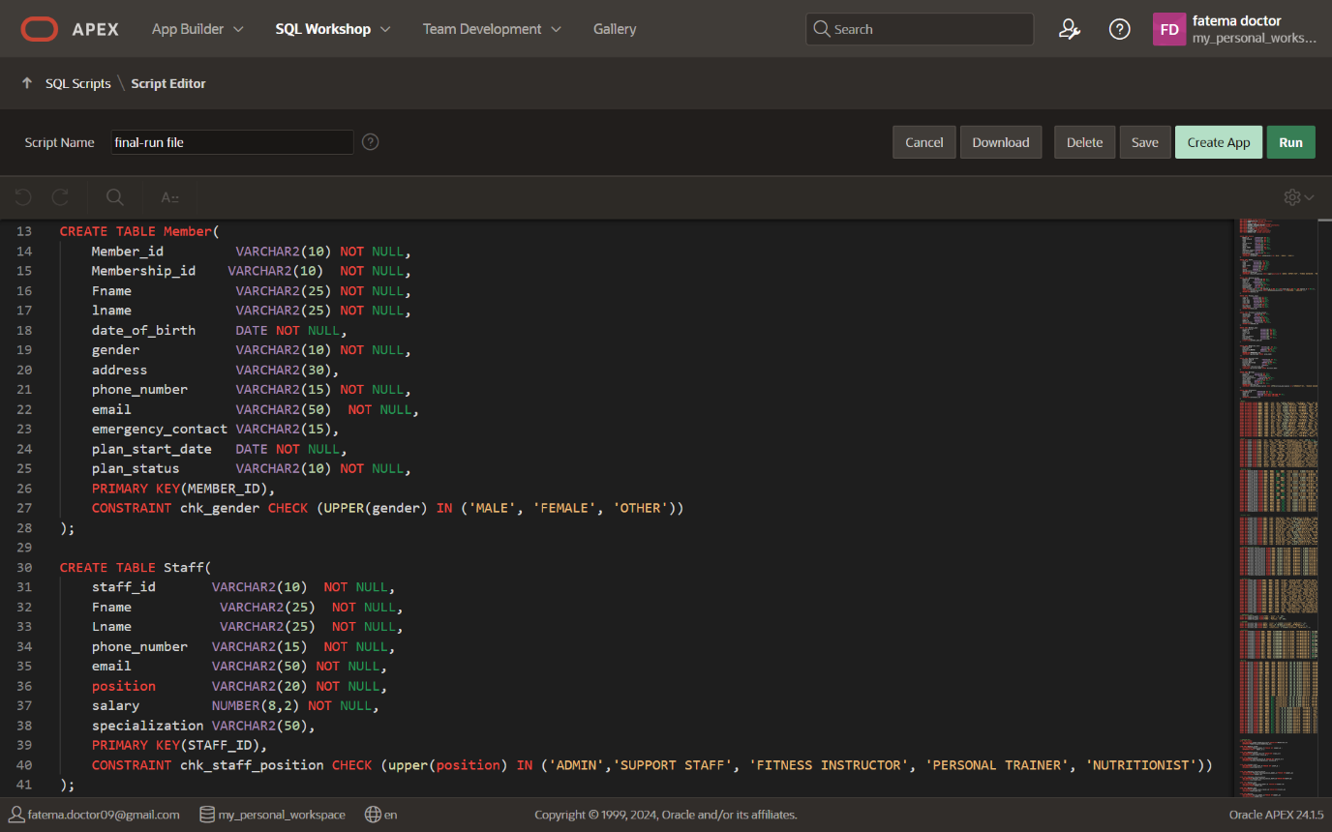**Staff**

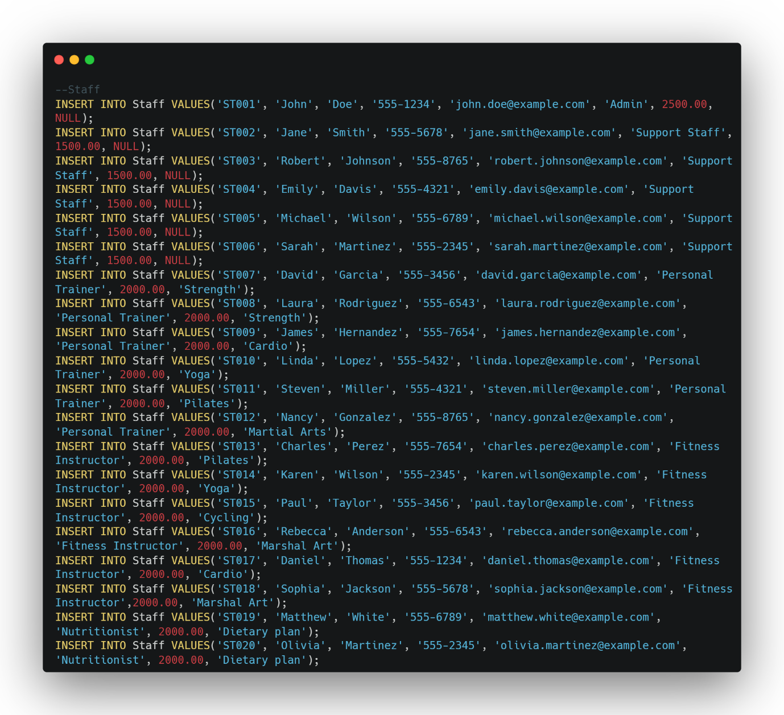*Fig. 6.5: Creating* ***‘STAFF’*** *table*

*Fig 6.6: Populating* ***‘STAFF’*** *table*

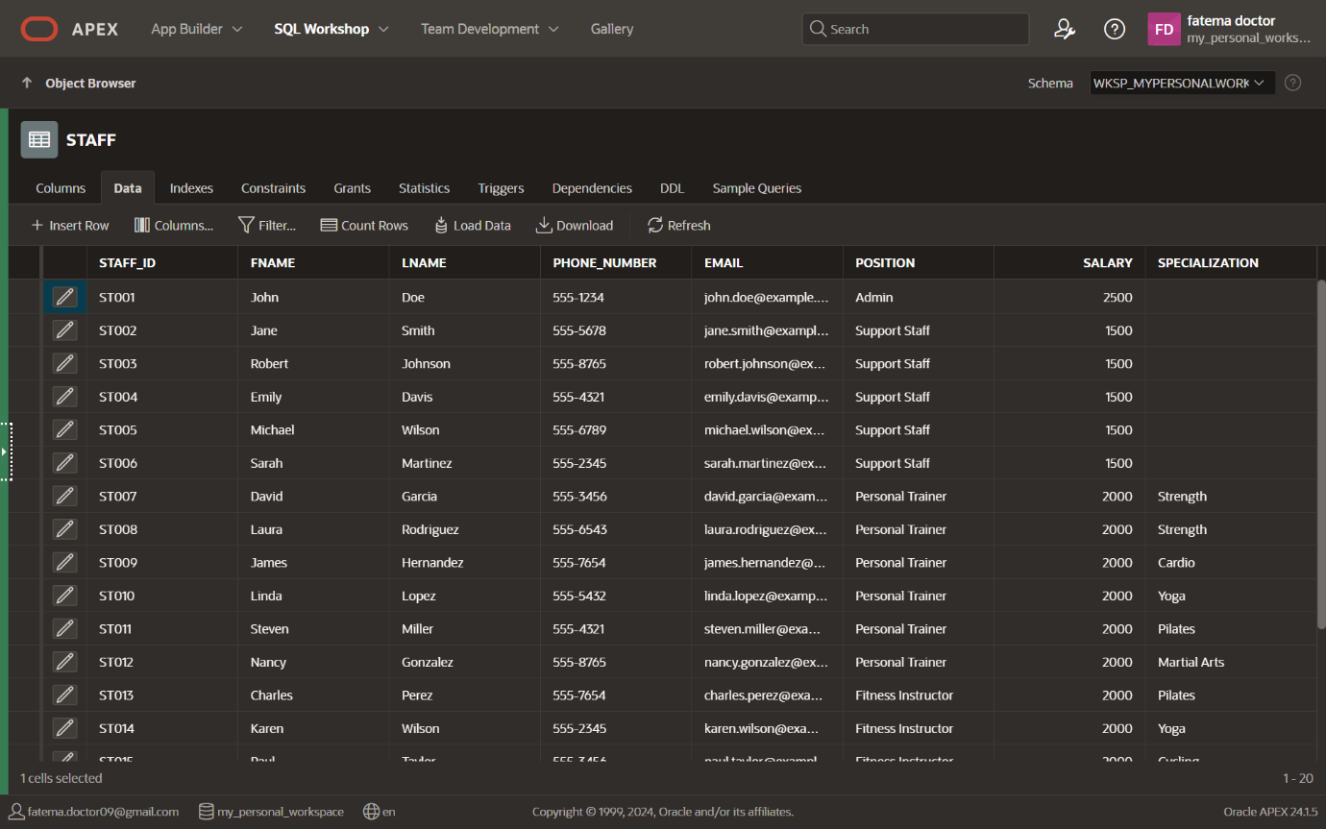*Fig 6.7:* ***‘STAFF’*** *table*

1. **Booking System**

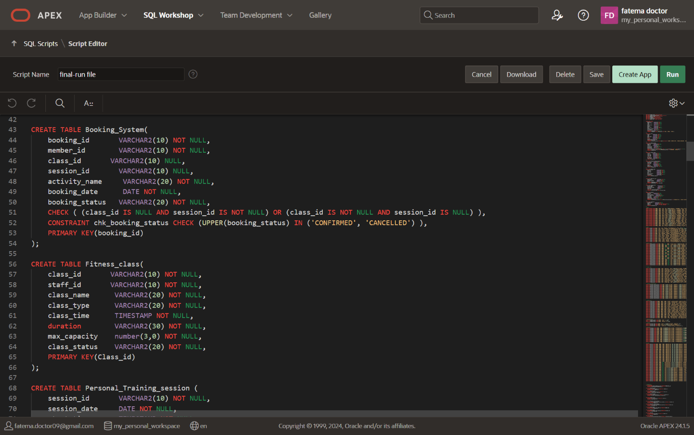

*Fig. 6.8: Creating* ***‘BOOKING SYSTEM’*** *table*

*Fig 6.9: Populating* ***‘BOOKING SYSTEM’*** *table* 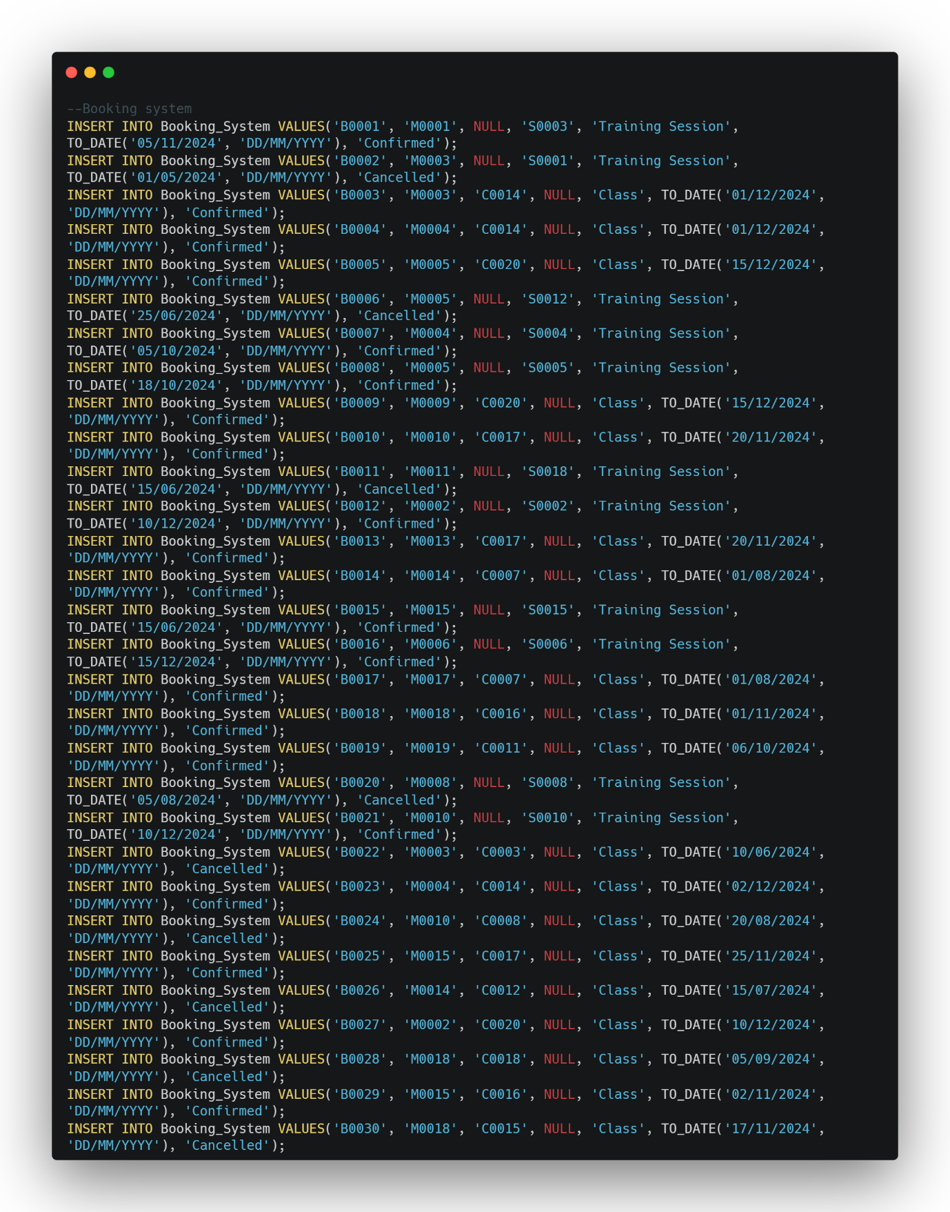

*Fig 6.10:* ***‘BOOKING SYSTEM’*** *table* 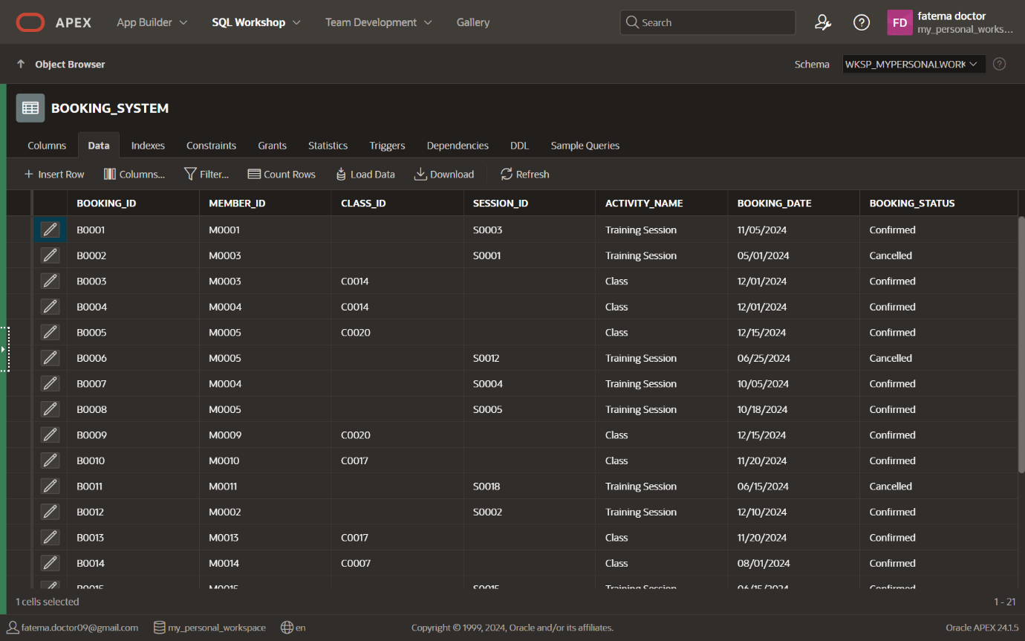



*Fig 6.11:* ***‘BOOKING SYSTEM’*** *table*

1. **Fitness Class**



*Fig. 6.12: Creating* ***‘FITNESS CLASS’*** *Table*

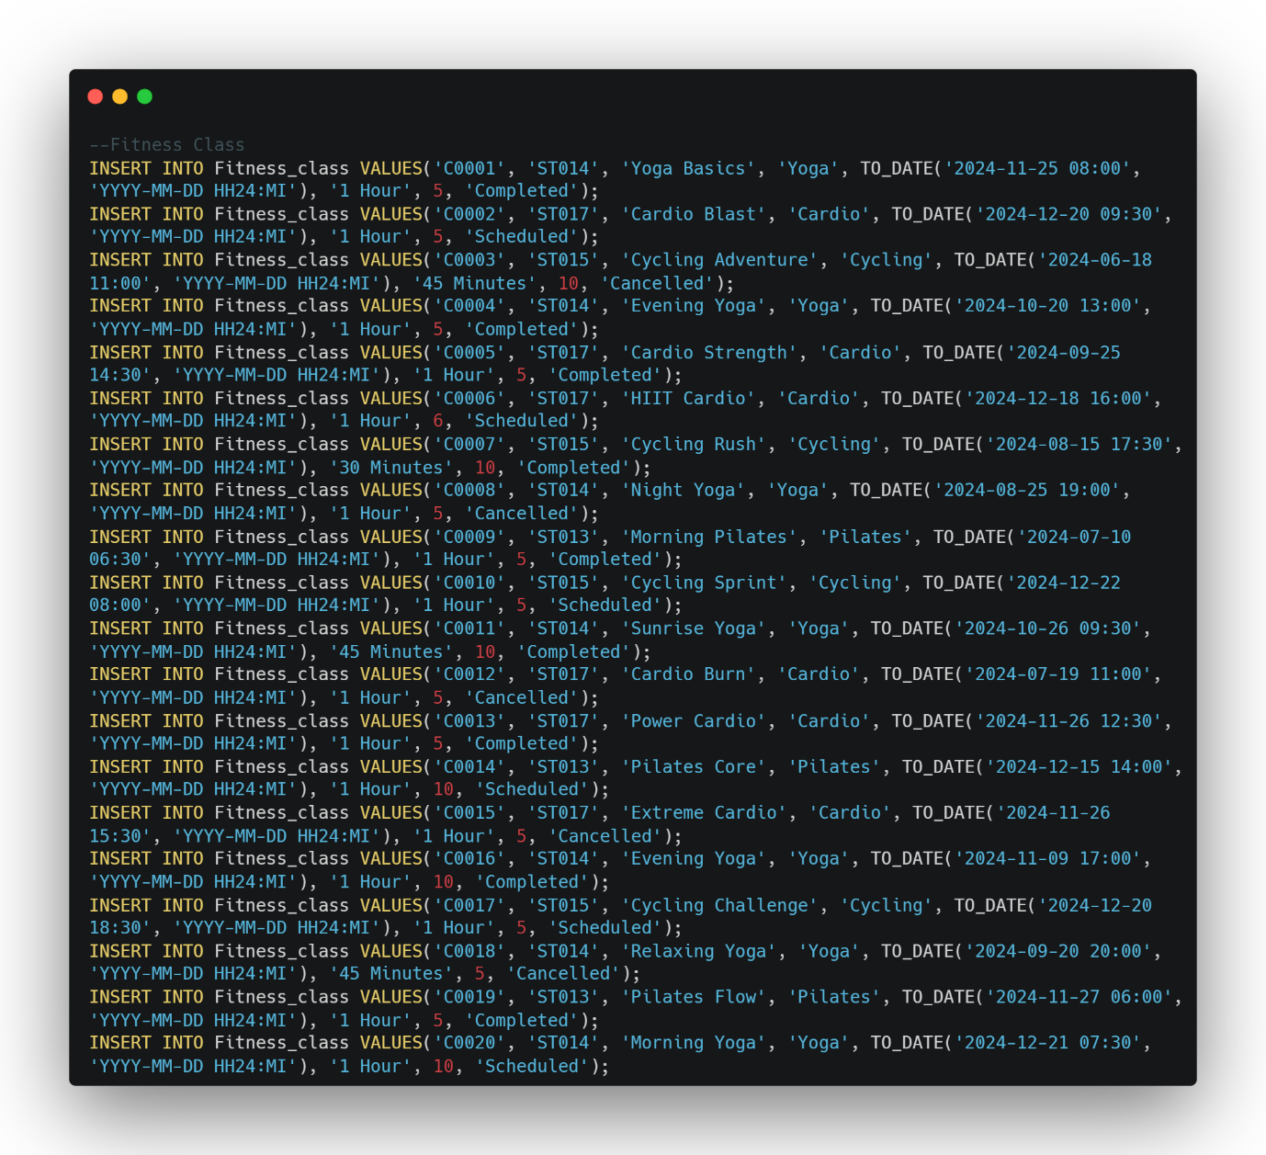

*Fig. 6.13: Populating* ***‘FITNESS CLASS’*** *Table*

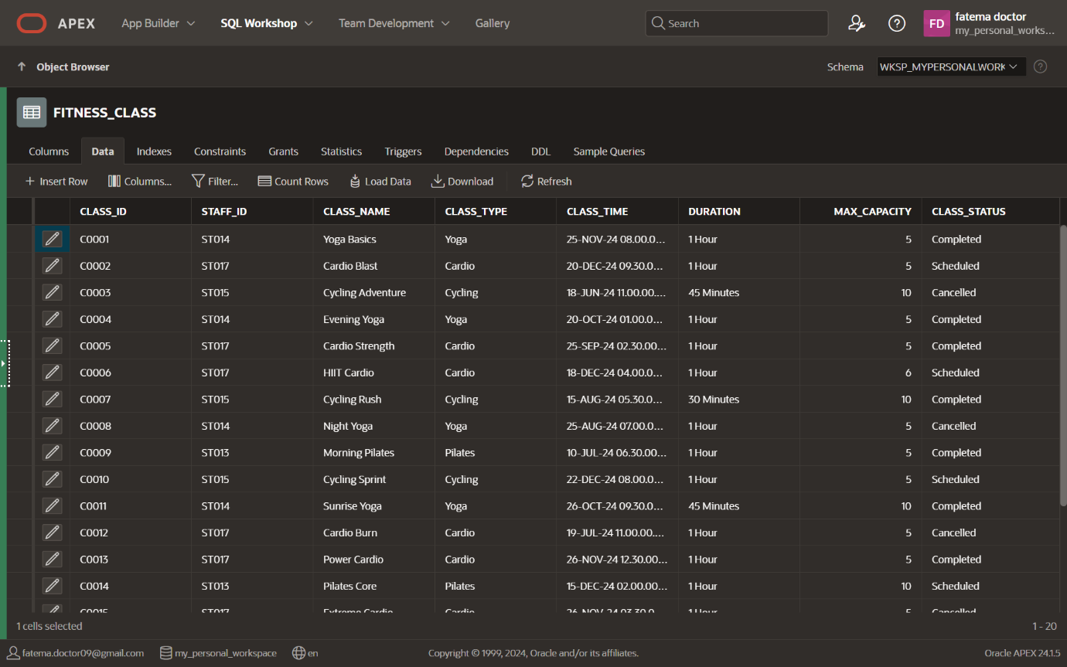*Fig. 6.14:* ***‘FITNESS CLASS’*** *Table*

1. 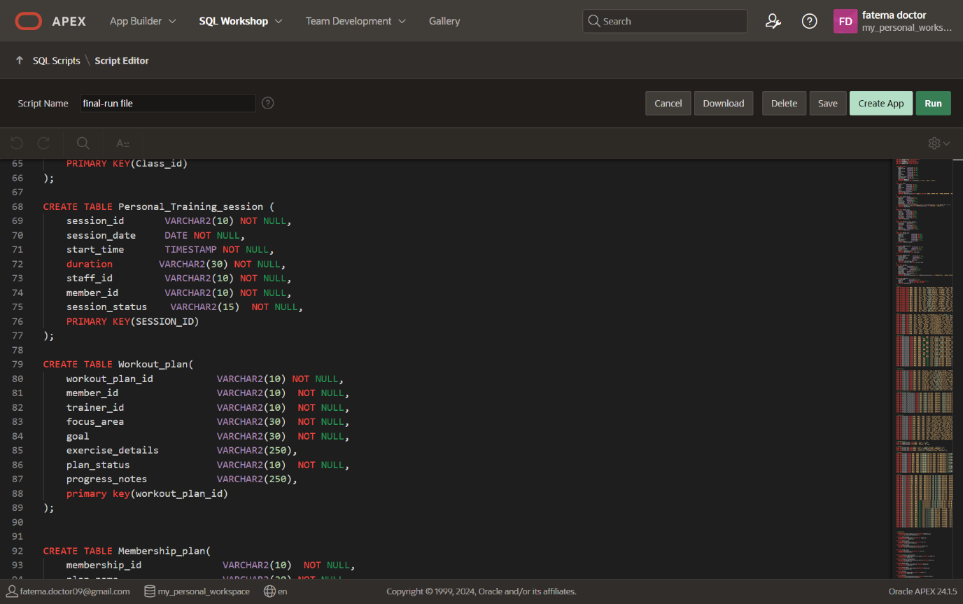**Personal Training Session**

*Fig. 6.15: Creating* ***‘PERSONAL TRAINING SESSION’*** *Table*

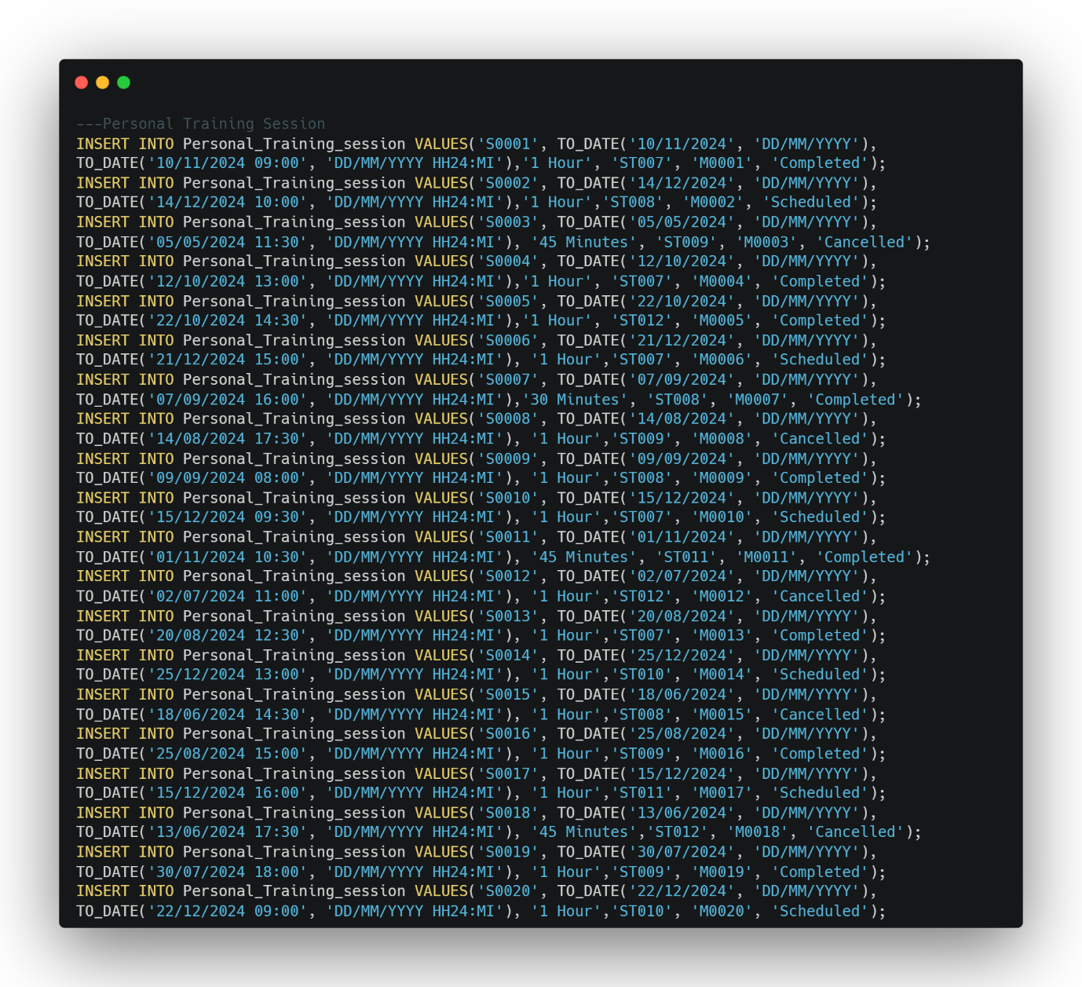

*Fig. 6.16: Populating* ***‘PERSONAL TRAINING SESSION’*** *Table*

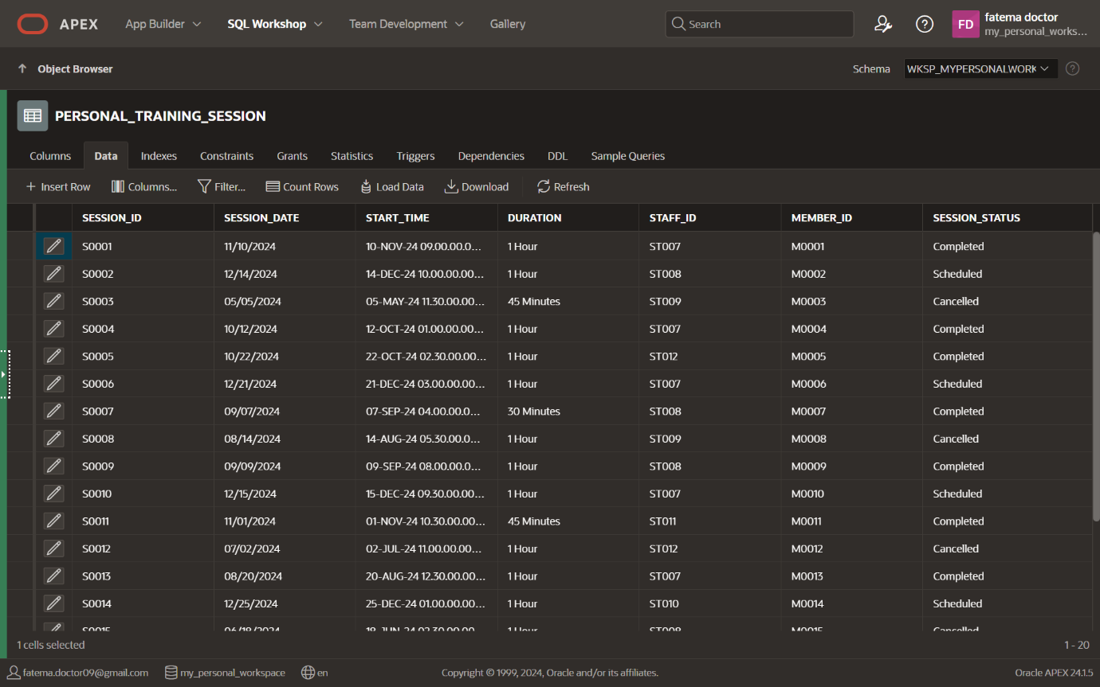

*Fig. 6.17:* ***‘PERSONAL TRAINING SESSION’*** *Table*

1. 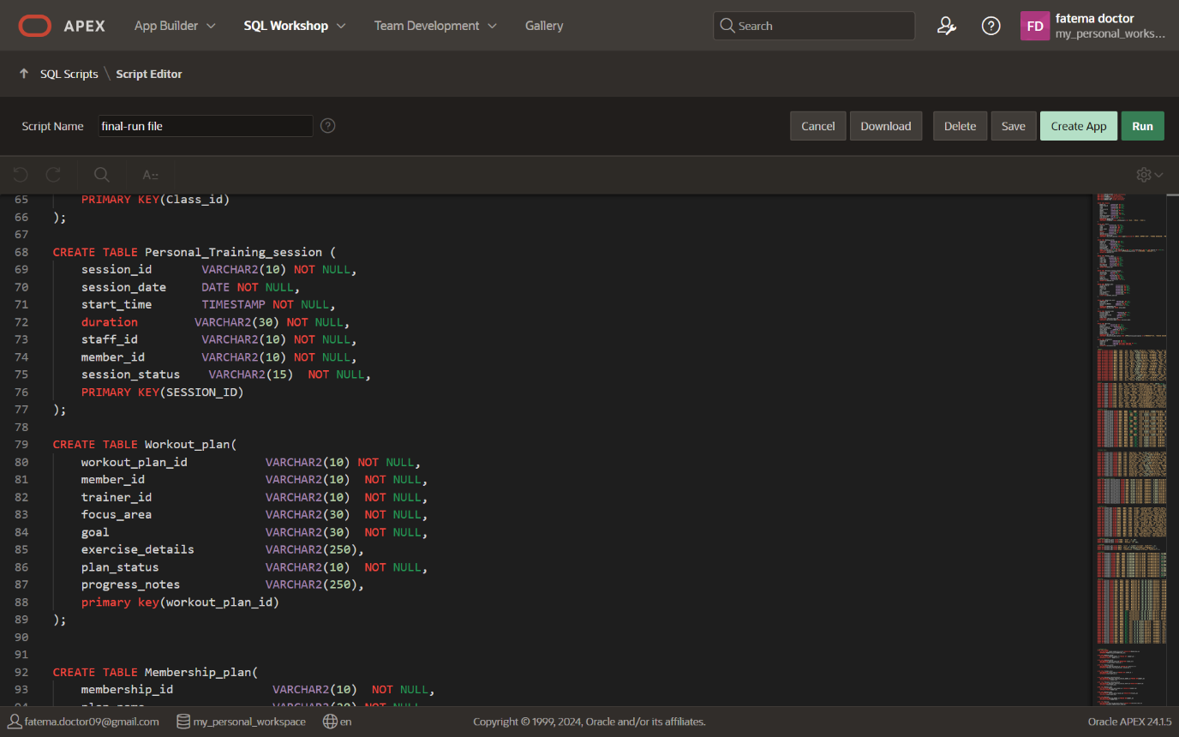**Workout Plan**

*Fig. 6.18: Creating* ***‘WORKOUT PLAN’*** *Table*

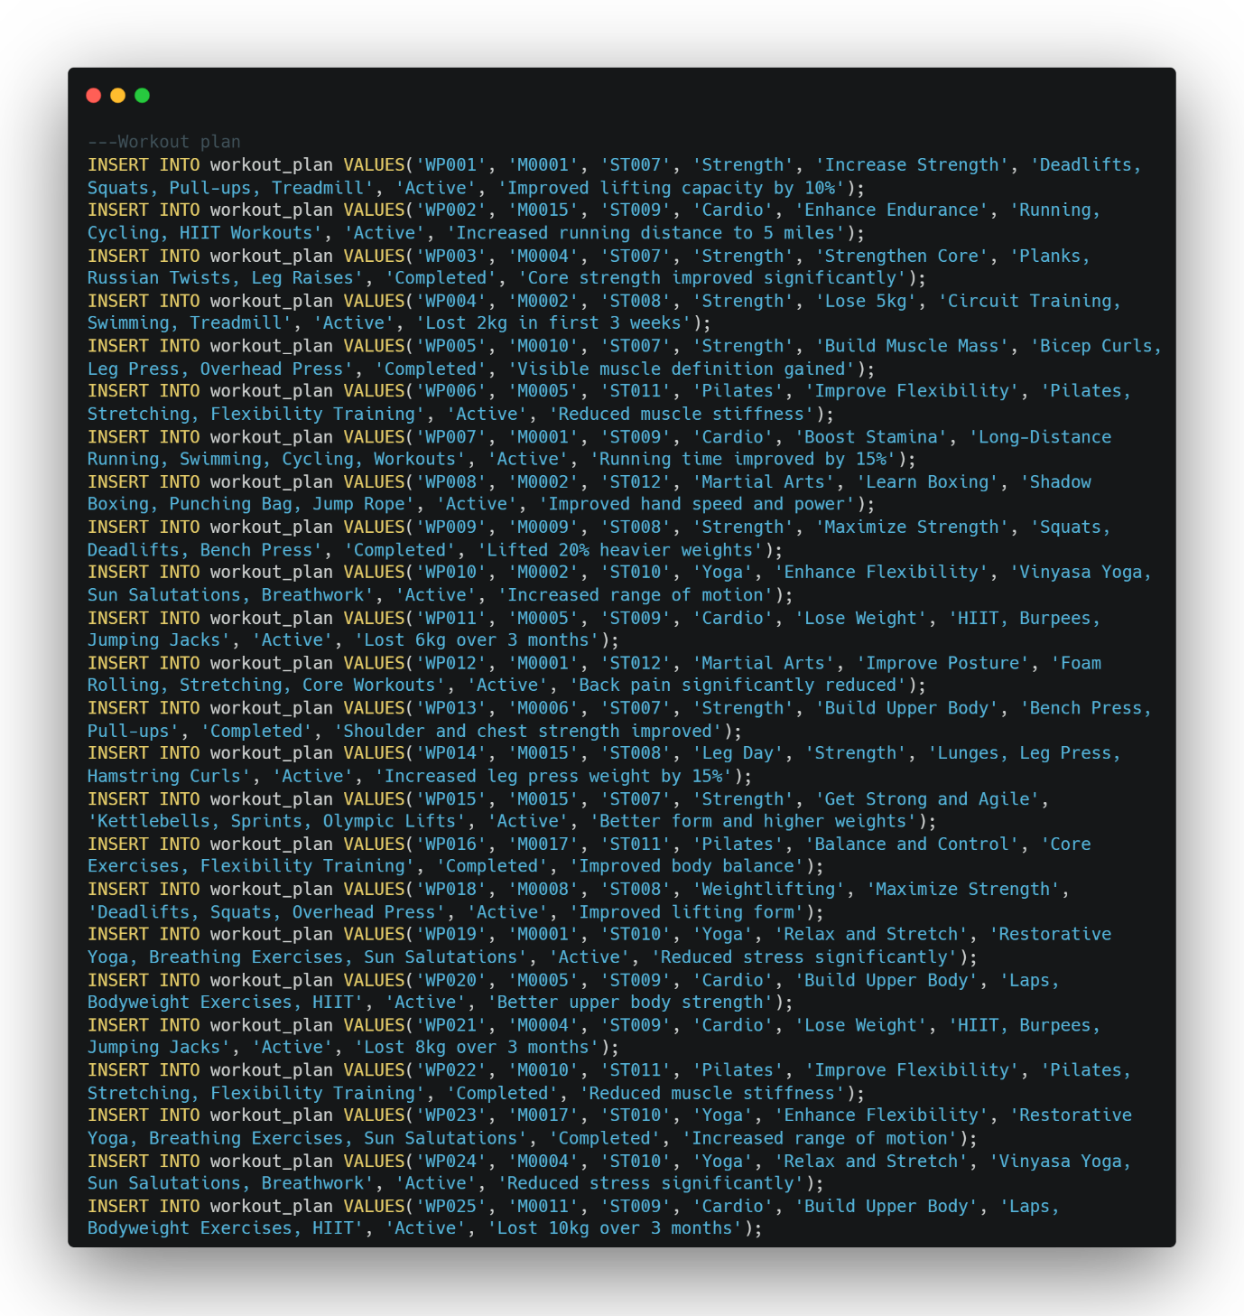

*Fig. 6.19: Populating* ***‘WORKOUT PLAN’*** *Table*

*Fig. 6.20:* ***‘WORKOUT PLAN’*** *Table* 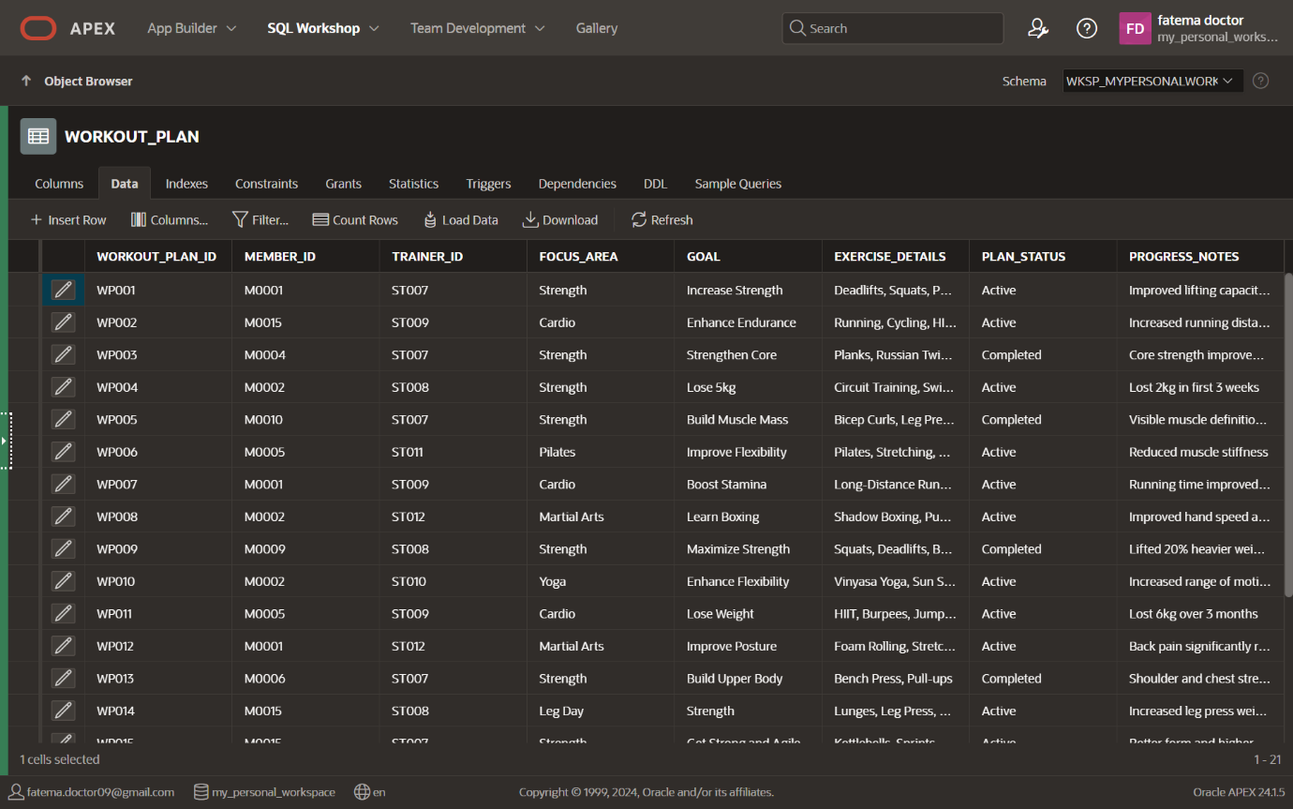

1. **Membership Plan**

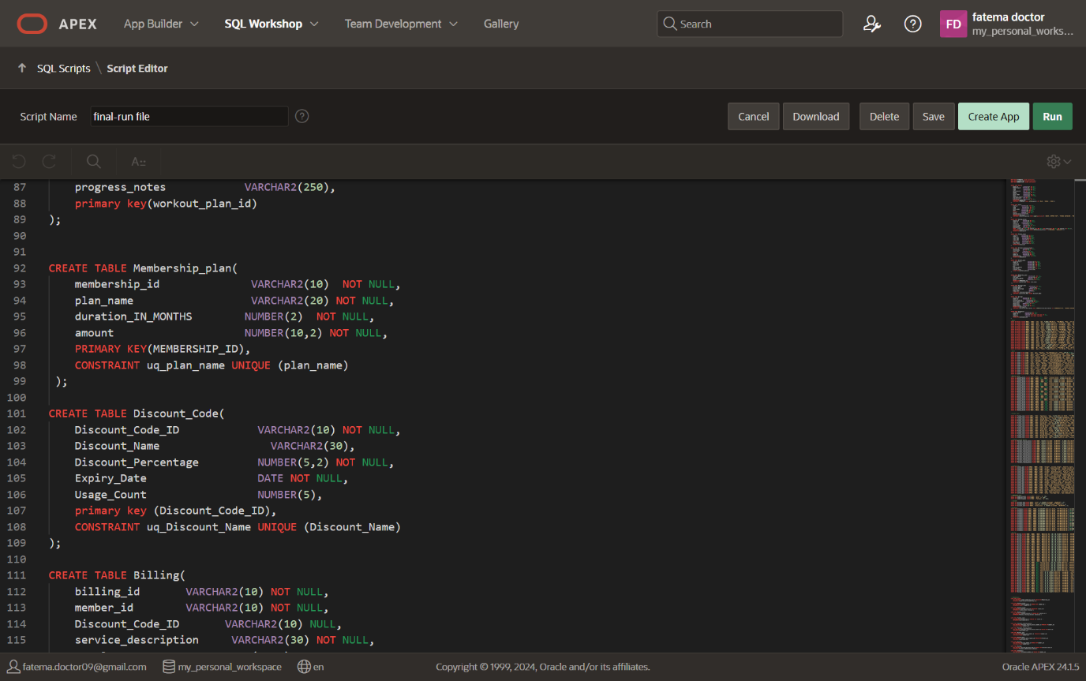

*Fig. 6.21: Creating* ***‘MEMBERSHIP PLAN’*** *Table*

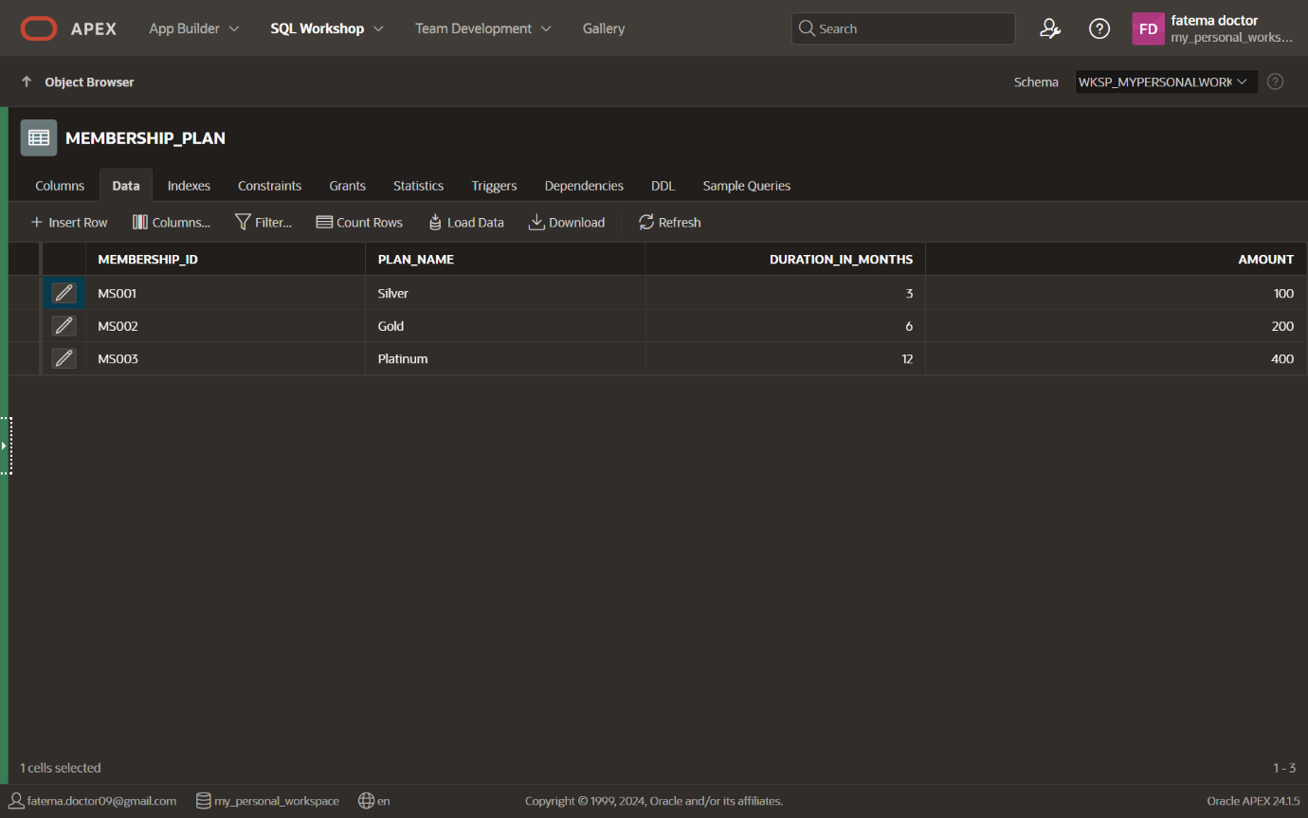 *Fig. 6.22: Populating* ***‘MEMBERSHIP PLAN’*** *Table* 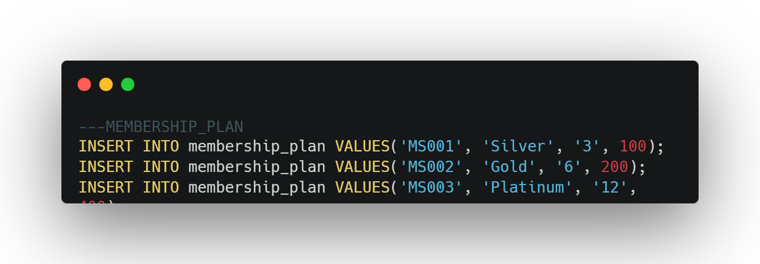

*Fig. 6.23:* ***‘MEMBERSHIP PLAN’*** *Table*

1. **Discount Code**

*Fig. 6.24: Creating* ***‘DISCOUNT CODE’*** *Table*

*Fig. 6.25: Populating* ***‘DISCOUNT CODE’*** *Table* 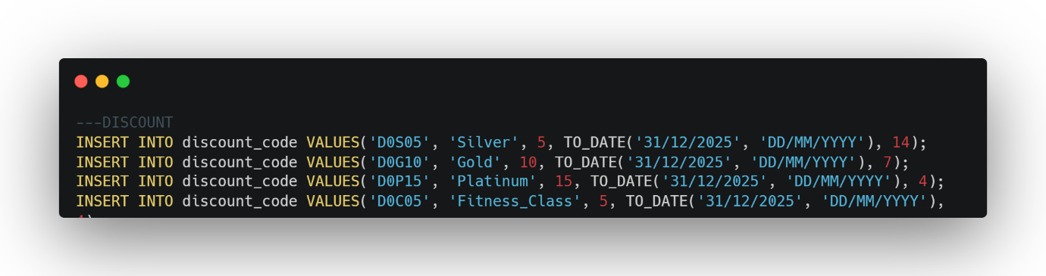

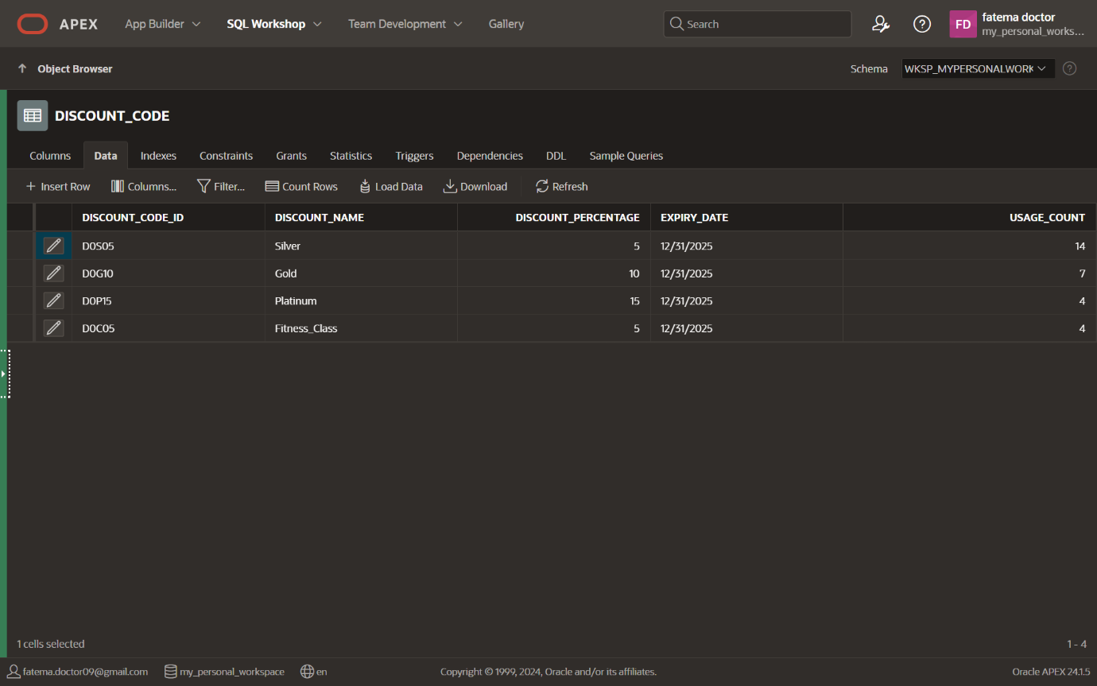

*Fig. 6.25:* ***‘DISCOUNT CODE’*** *Table*

1. 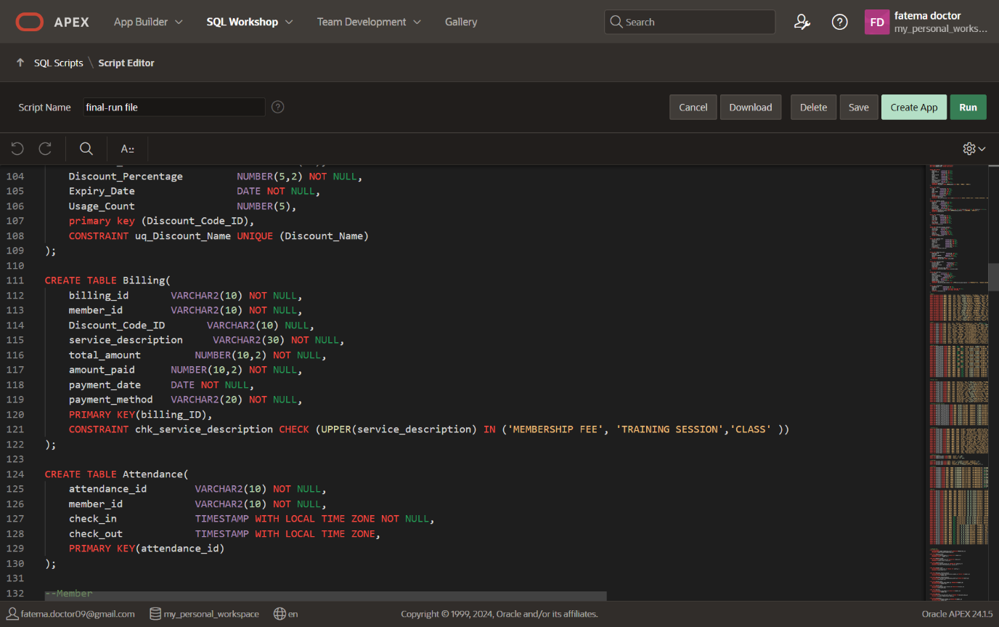**Billing**

*Fig. 6.24: Creating* ***‘BILLING’*** *Table*

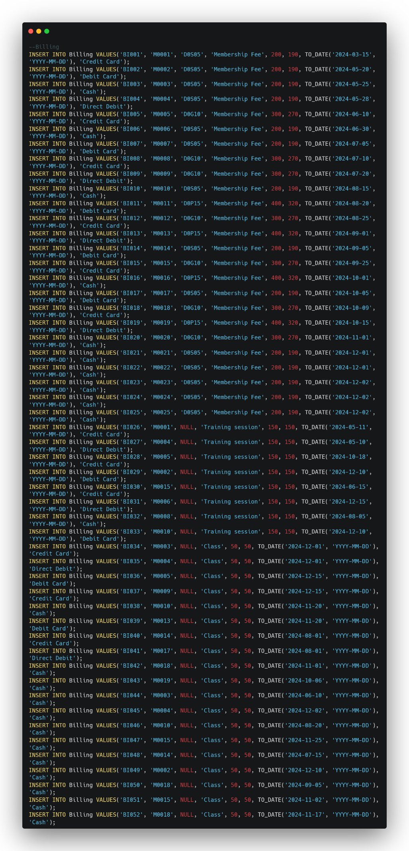 *Fig. 6.25: Populating* ***‘BILLING’*** *Table*

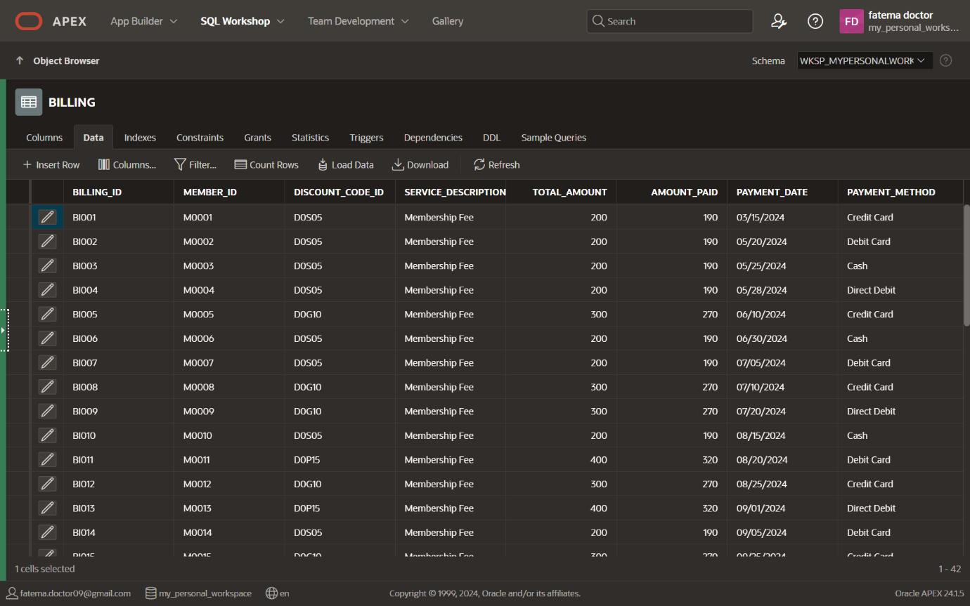*Fig. 6.25:* ***‘BILLING’*** *Table*

1. **Attendance**



*Fig. 6.25: Creating* ***‘ATTENDANCE’*** *Table*

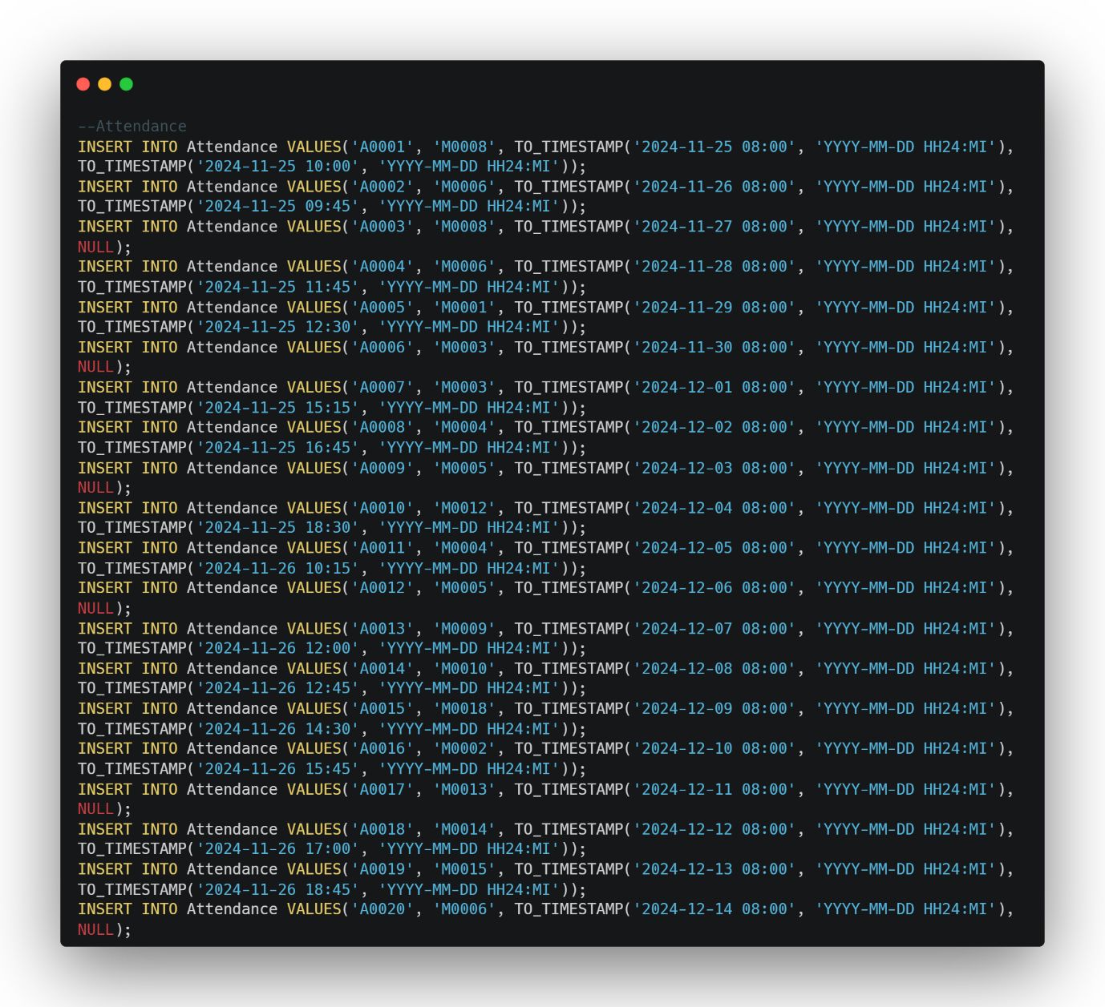

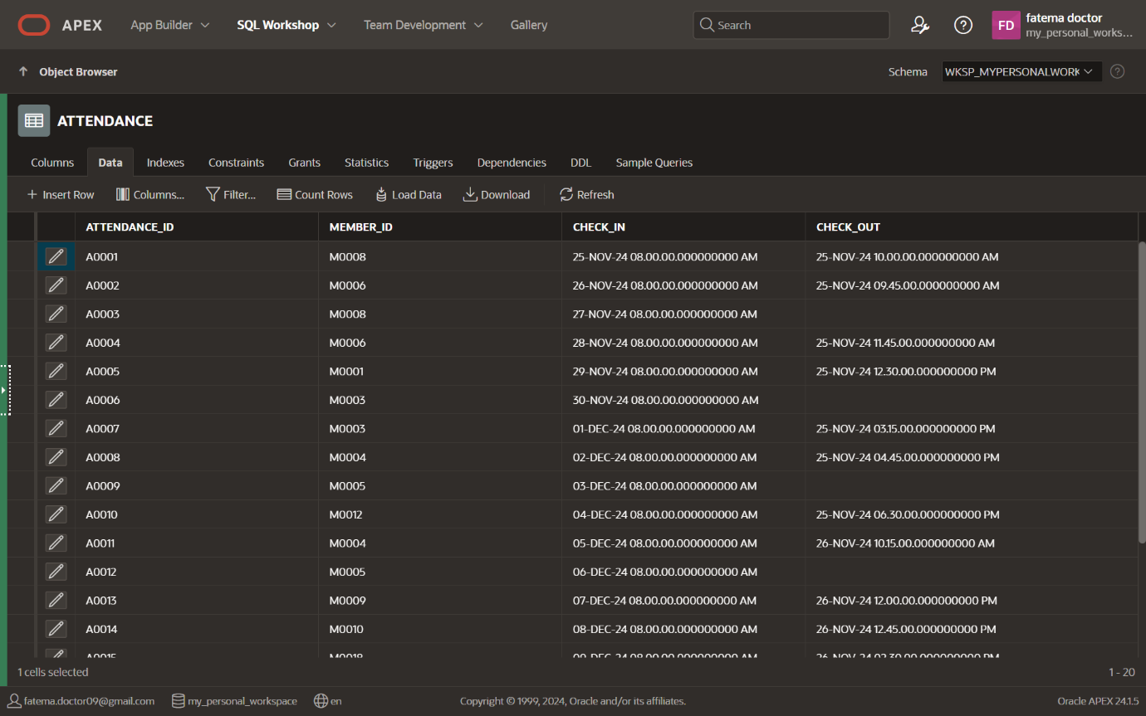*Fig. 6.25: Populating* ***‘ATTENDANCE’*** *Table*

*Fig. 6.25:* ***‘ATTENDANCE’*** *Table*

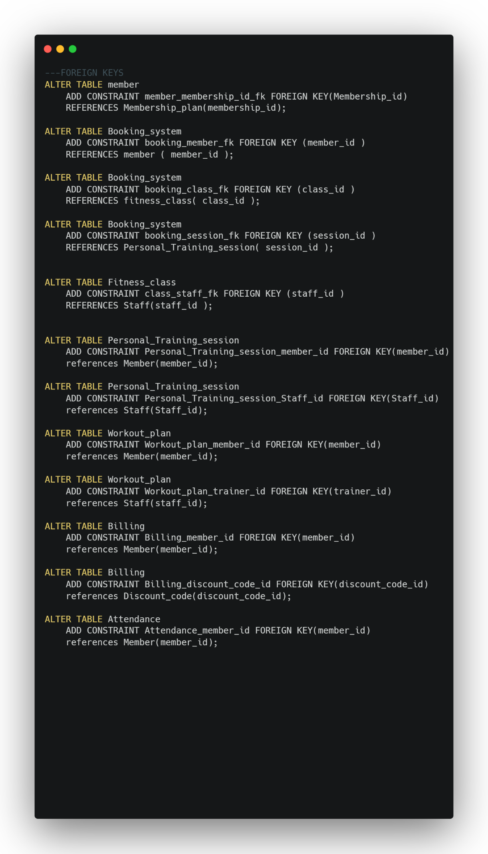

*Fig. 6.25: Adding constraints*

# **7. SQL Queries and Results**

SQL queries for each of the following tasks, along with sample results:

## *Query 1:*

**List of all fitness classes with schedules and instructor names.**

SELECT

FC.class_id,

FC.class_name, FC.class_type,

FC.class_time,

S.fname || ' ' || S.lname AS instructor_name

FROM

Fitness_class FC

JOIN

Staff S

ON FC.staff_id = S.staff_id

ORDER BY CLASS_ID;

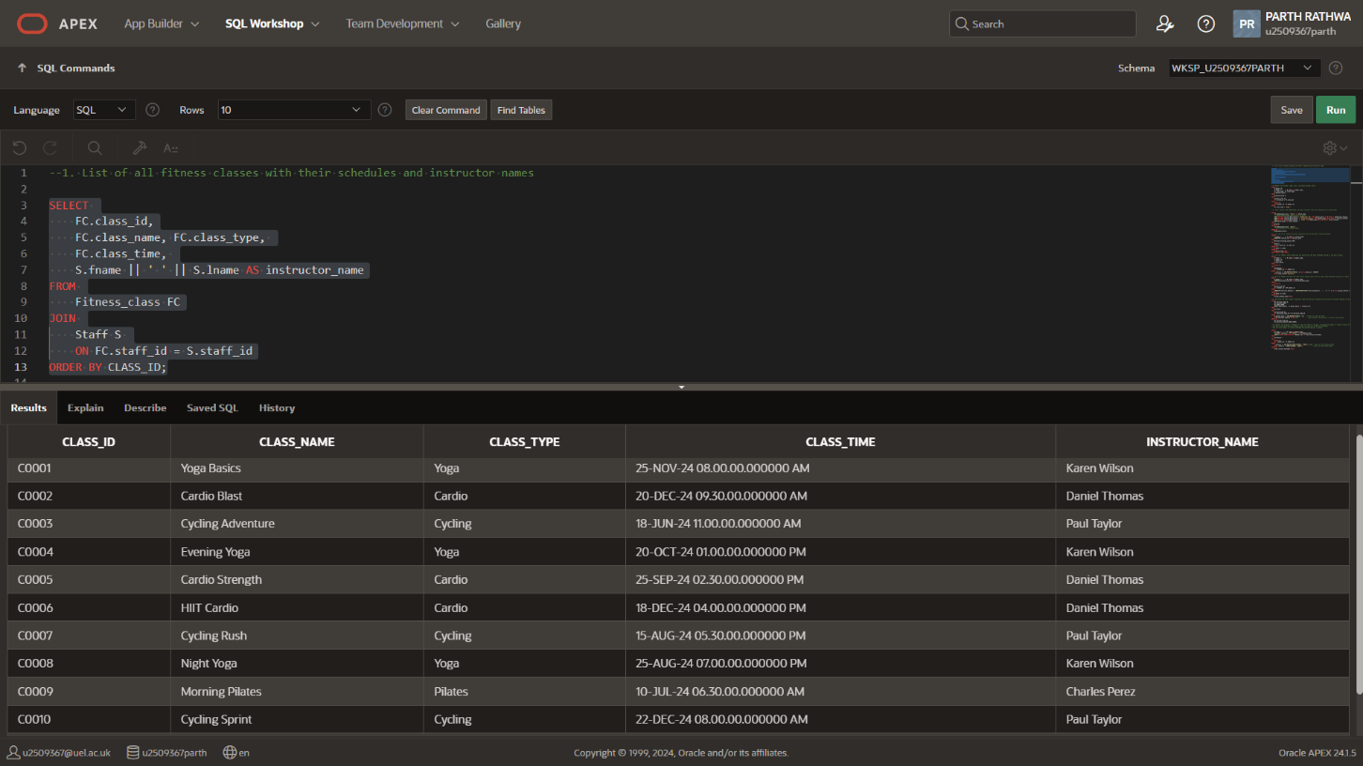

*Fig 7.1 Output: Query 1*

## *Query 2:*

**Members who booked yoga classes, including booking status.**

SELECT

M.member_ID,

M.fname || ' ' || M.lname AS member_name,

fc.class_name, fc.class_type,

B.booking_status

FROM

Booking_system B

JOIN

Fitness_class FC

ON B.class_id = FC.class_id

JOIN

Member M

ON B.member_id = M.member_id

WHERE

FC.class_type = 'Yoga';

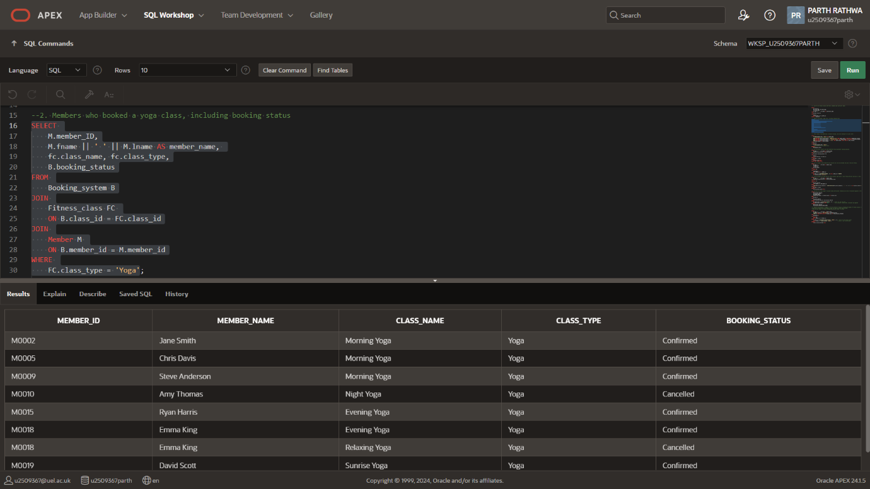

*Fig 7.2 Output: Query 2*

## *Query 3:*

**Total revenue from memberships, personal training, and class bookings for a given month.**

SELECT

TO_CHAR(payment_date, 'Month') AS month_name,

-- EXTRACT(MONTH FROM payment_date) AS month,

SUM(CASE WHEN service_description = 'Membership Fee' THEN amount_paid ELSE 0 END)

AS membership_revenue,

SUM(CASE WHEN service_description = 'Training session' THEN amount_paid ELSE 0 END)

AS session_revenue,

SUM(CASE WHEN service_description = 'Class' THEN amount_paid ELSE 0 END)

AS class_revenue,

SUM(amount_paid) AS total_revenue

FROM

Billing

GROUP BY

TO_CHAR(payment_date, 'Month')

-- extract(month from payment_date)

ORDER BY

MIN(payment_date);

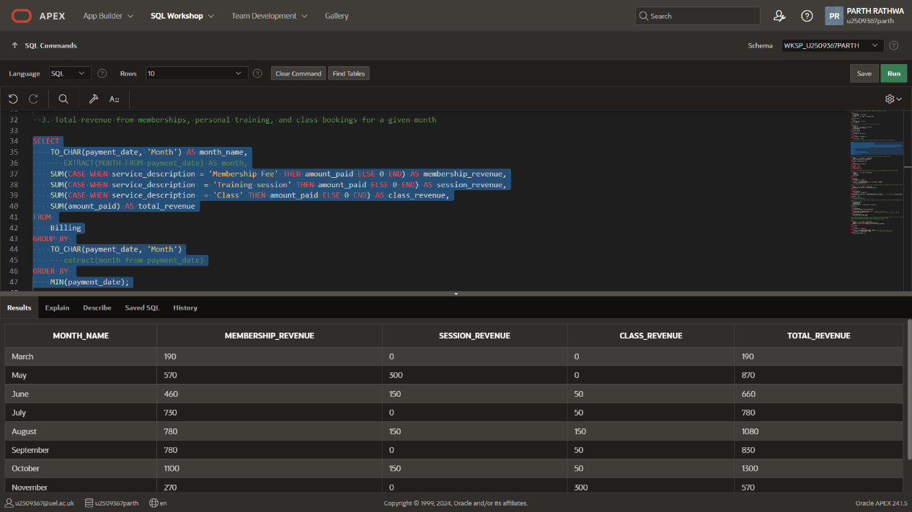

*Fig 7.3 Output: Query 3*

## *Query 4:*

**Top 5 trainers based on personal training sessions conducted.**

SELECT

S.fname || ' ' || S.lname AS trainer_name,

COUNT(PTS.session_id) AS session_count

FROM

Personal_Training_session PTS

JOIN

Staff S

ON PTS.staff_id = S.staff_id

GROUP BY

S.fname, S.lname

ORDER BY

session_count DESC

FETCH FIRST 5 ROWS ONLY;

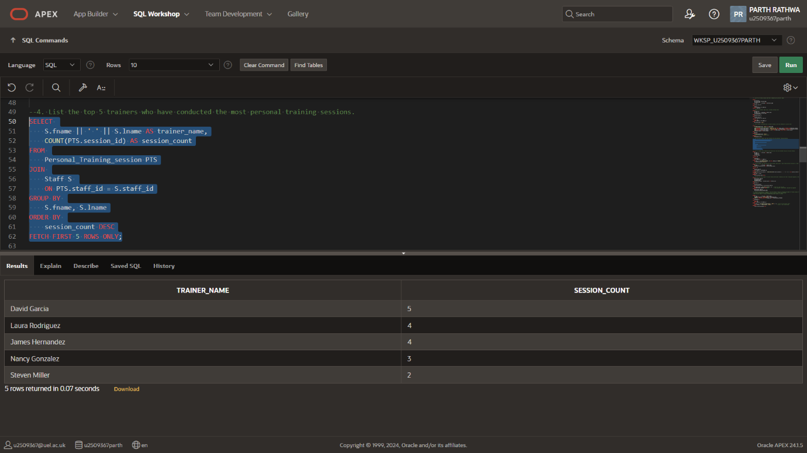

*Fig 7.4 Output: Query 4*

## *Query 5:*

**Members with expired memberships who attended in the last 30 days.**

SELECT

M.fname || ' ' || M.lname AS member_name,

m.member_id,

A.check_in,

m.plan_status

FROM

Member M

JOIN

Attendance A

ON M.member_id = A.member_id

WHERE

A.check_in >= ADD_MONTHS(SYSDATE, -1) and a.check_in < SYSDATE

AND m.plan_status='Inactive';

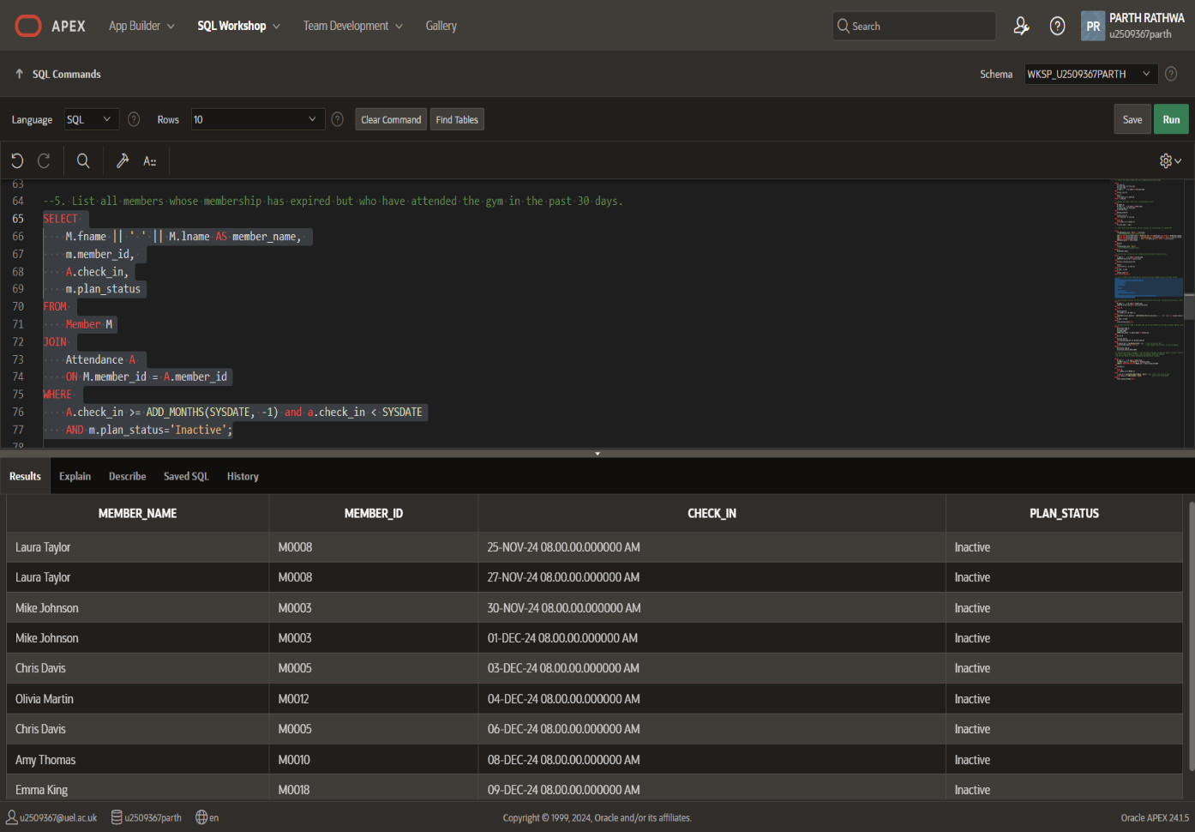

*Fig 7.5 Output: Query 5*

## *Query 6:*

**Members with active workout plans having at least three exercises.**

SELECT

M.fname || ' ' || M.lname AS member_name,

COUNT(WP.workout_plan_id) AS active_workout_plans

FROM

Member M

JOIN

Workout_plan WP

ON M.member_id = WP.member_id

WHERE

LENGTH(WP.exercise_details) - LENGTH(REPLACE(WP.exercise_details, ',', '')) + 1 >= 3 and wp.plan_status='Active'

GROUP BY

M.fname, M.lname

ORDER BY

active_workout_plans DESC;

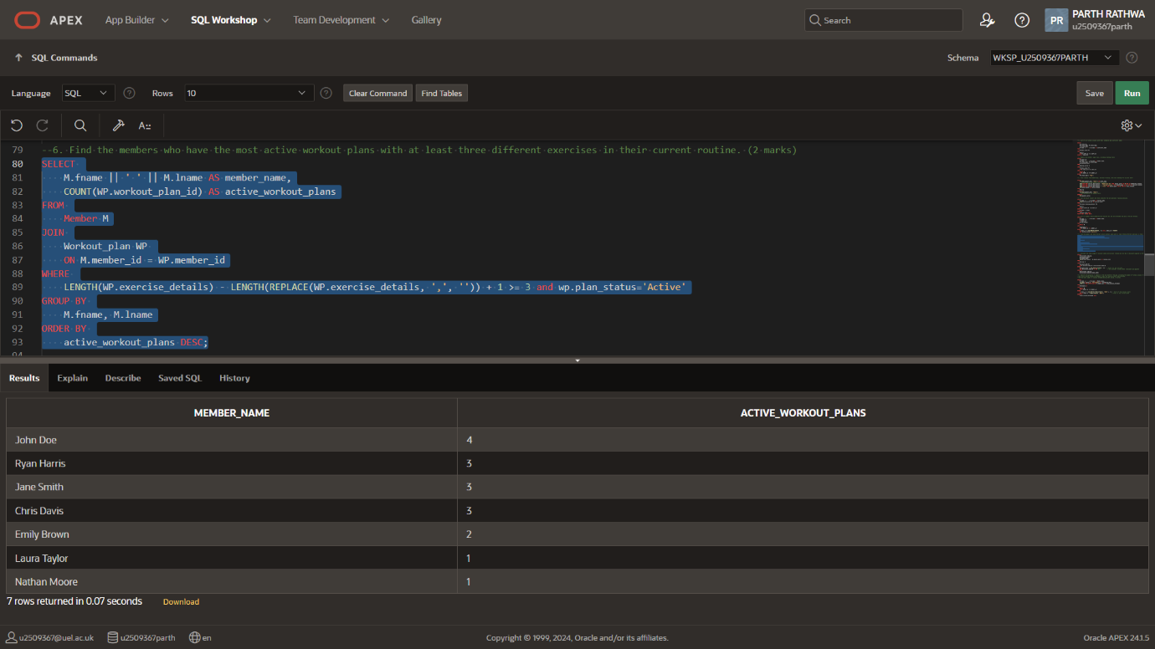

*Fig 7.6 Output: Query 6*

## 

## *Query 7:*

**Total discount code usage and revenue lost due to discounts in the last year.**

SELECT

DC.discount_code_id,

DC.discount_name,

DC.USAGE_COUNT,

SUM(B.total_amount - B.amount_paid) AS revenue_lost

FROM

Billing B

JOIN

Discount_Code DC

ON B.Discount_Code_ID = DC.Discount_Code_ID

WHERE

B.payment_date >= ADD_MONTHS(SYSDATE, -12)

-- Filter for the last year

AND B.Discount_Code_ID IS NOT NULL

-- Only consider records where a discount was applied

GROUP BY

DC.discount_code_id,

DC.discount_name,DC.USAGE_COUNT;

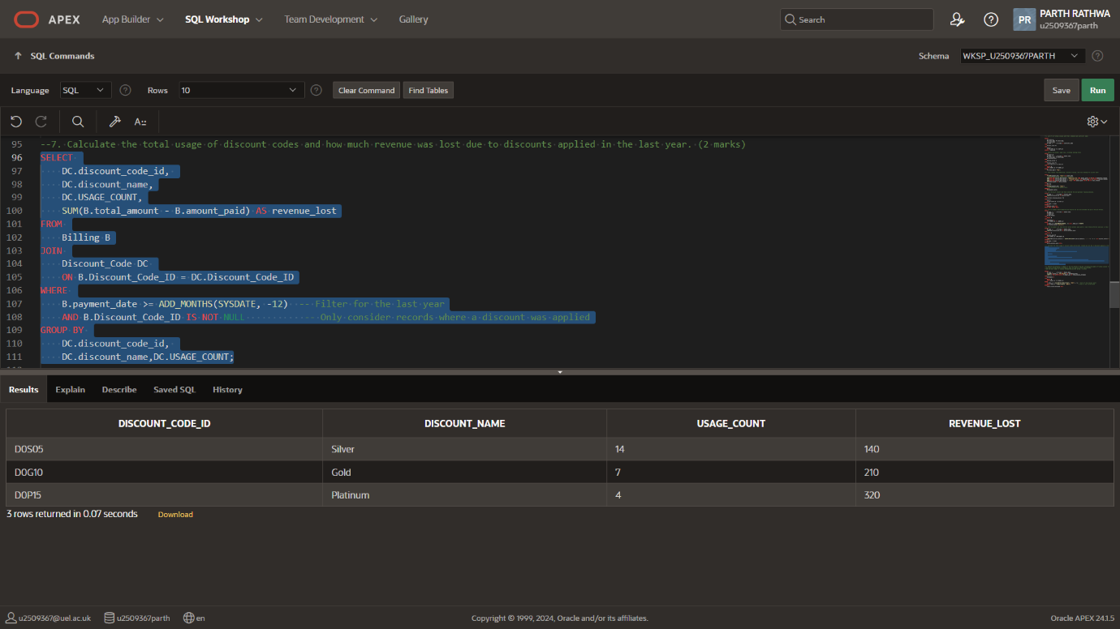

*Fig 7.7 Output: Query 7*

## *Query 8:*

**Members' progress in the last month, including classes attended and attendance dates.**

SELECT

M.Fname || ' ' || M.Lname AS Member_Name,

TO_CHAR(A.check_in, 'YYYY-MM-DD') AS Attendance_Date,

COUNT(*) OVER (PARTITION BY M.Member_id) AS Total_Classes_Attended

FROM

Attendance A

JOIN

Member M

ON A.member_id = M.Member_id

WHERE

A.check_in >= ADD_MONTHS(TRUNC(SYSDATE, 'MONTH'), -1)

-- Start of the previous month

AND A.check_in < TRUNC(SYSDATE, 'MONTH')

-- Start of the current month

ORDER BY

Total_Classes_Attended DESC;

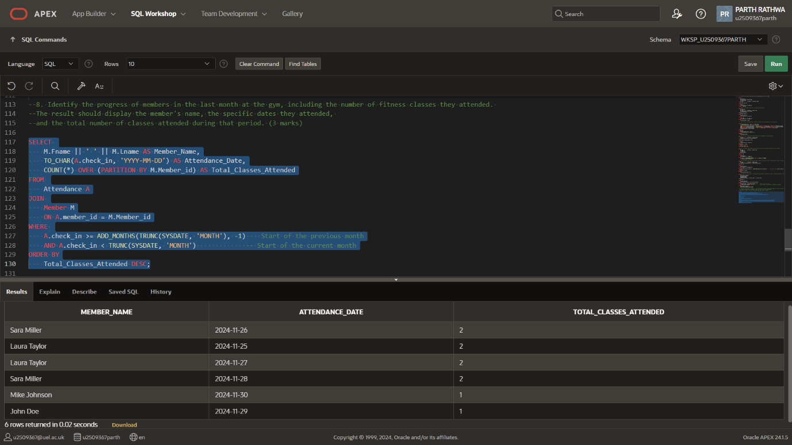*Fig 7.8 Output: Query 8*

# **8. Triggers and Stored Procedures**

## *Trigger 1:*

**Set membership status to "Inactive" when a membership expires.**

CREATE OR REPLACE TRIGGER trg_set_membership_inactive

BEFORE INSERT OR UPDATE OF plan_start_date, Membership_id ON Member

FOR EACH ROW

DECLARE

v_duration NUMBER; -- To hold the duration of the membership in months

v_end_date DATE; -- To calculate the expiration date

BEGIN

-- Get the membership duration from the Membership_plan table

SELECT TO_NUMBER(duration_IN_MONTHS)

INTO v_duration

FROM Membership_plan

WHERE membership_id = :NEW.Membership_id;

-- Calculate the expiration date

v_end_date := ADD_MONTHS(:NEW.plan_start_date, v_duration);

-- Set the plan_status to 'Inactive' if the membership has expired

IF v_end_date < SYSDATE THEN

:NEW.plan_status := 'Inactive';

ELSE

:NEW.plan_status := 'Active';

END IF;

END;

/

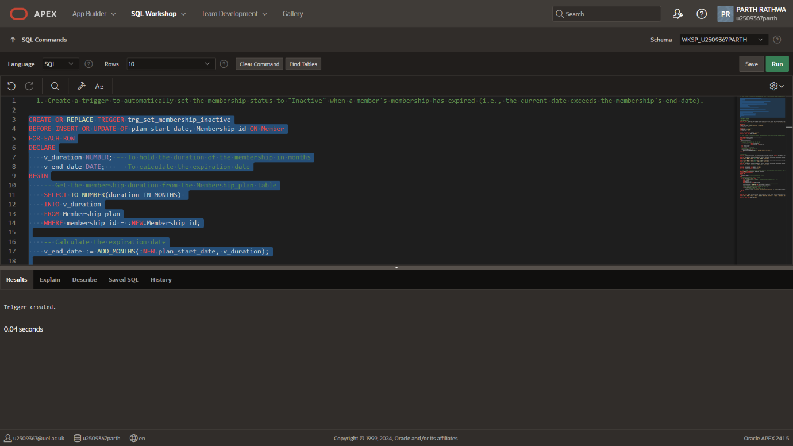

*Fig 8.1 Creating the trigger*

*Testing the trigger*

--WHEN INSERING A ROW

INSERT INTO Member (Member_id, Membership_id, Fname, lname, date_of_birth, gender, address, phone_number, email, emergency_contact, plan_start_date, plan_status)

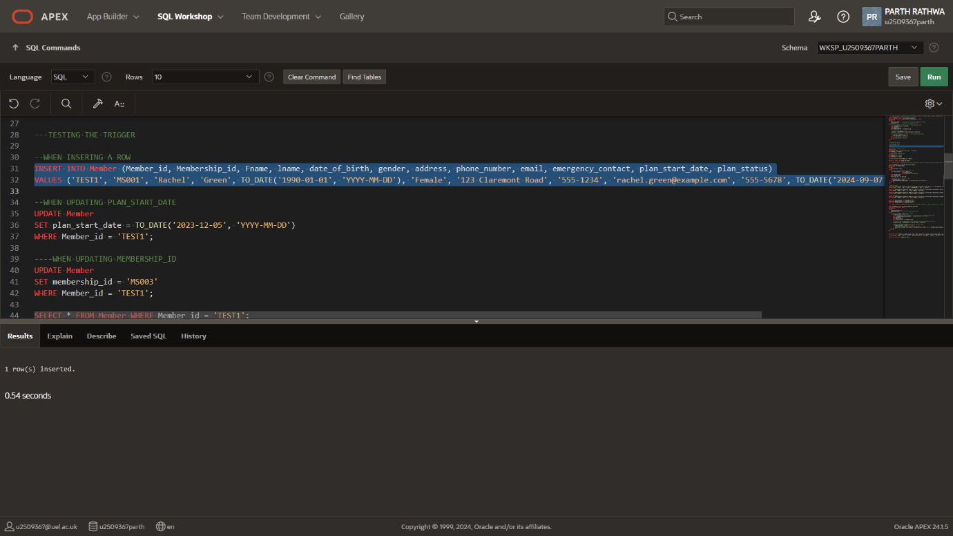VALUES ('TEST1', 'MS001', 'Rachel', 'Green', TO_DATE('1990-01-01', 'YYYY-MM-DD'), 'Female', '123 Claremont Road', '555-1234', 'rachel.green@example.com', '555-5678', TO_DATE('2024-09-07', 'YYYY-MM-DD'), 'Active');

*Fig 8.2 Trigger 1: Inserting a test row*

**--WHEN UPDATING PLAN_START_DATE**

UPDATE Member

SET plan_start_date = TO_DATE('2023-12-05', 'YYYY-MM-DD')

WHERE Member_id = 'TEST1';

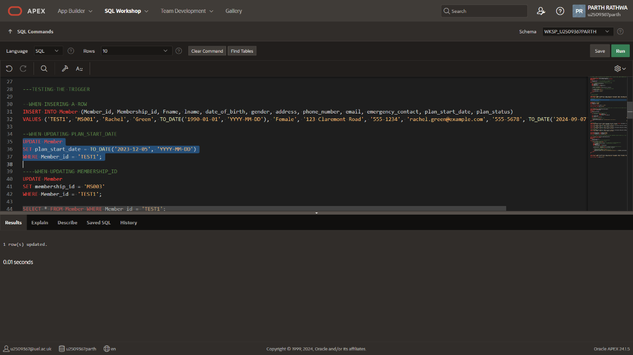

*Fig 8.3 Trigger 1: Updating the test date*

**----WHEN UPDATING MEMBERSHIP_ID**

UPDATE Member

SET membership_id = 'MS003'

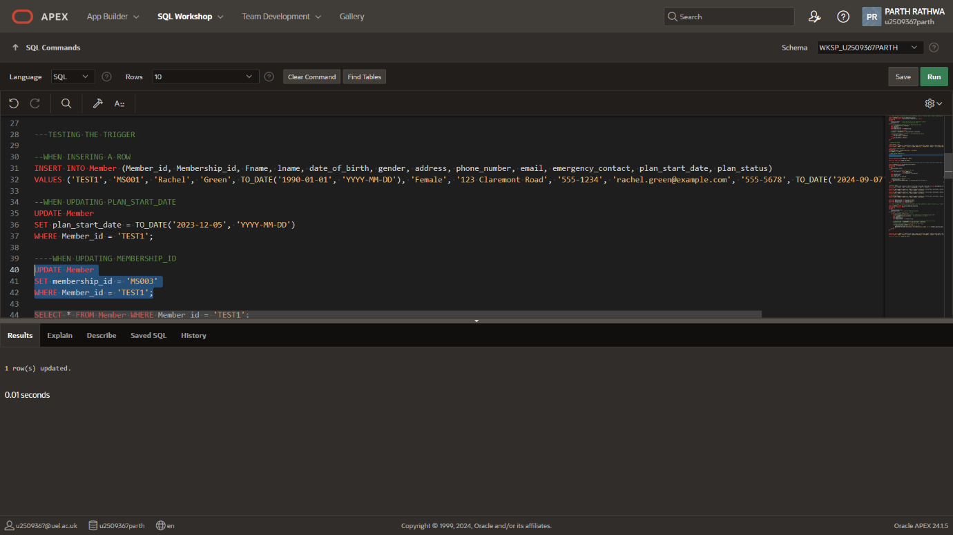WHERE Member_id = 'TEST1';

*Fig 8.4 Trigger 1: Updating membership ID*

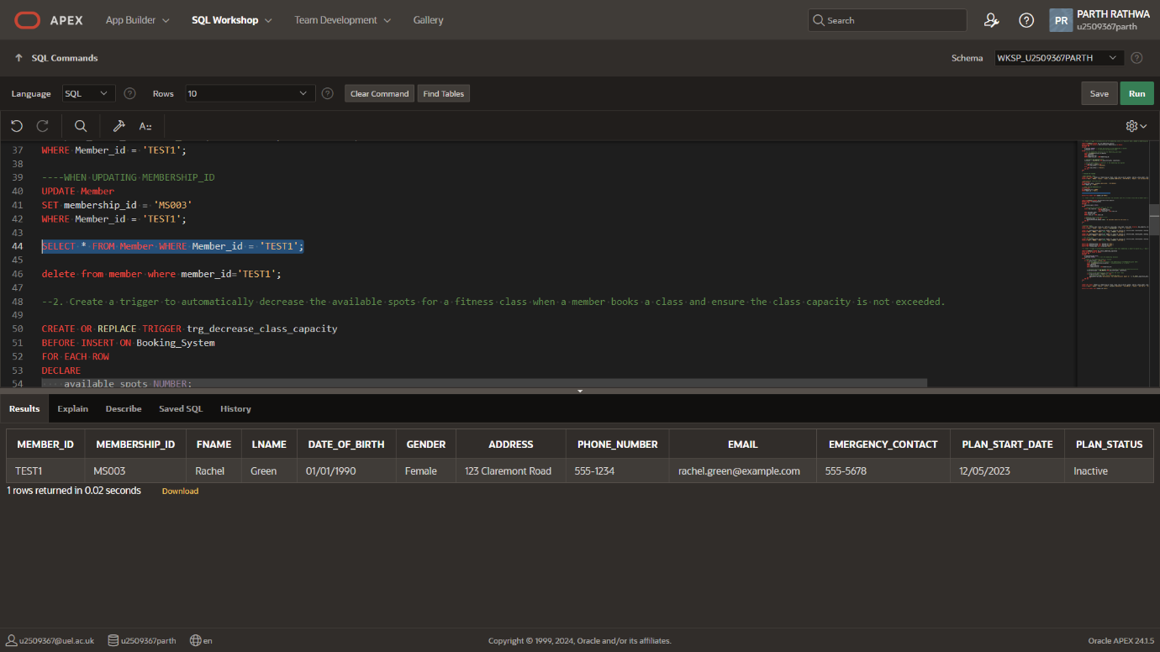SELECT * FROM Member WHERE Member_id = 'TEST1';

*Fig 8.5 Trigger 1: Member status automatically set to* ***‘inactive’***

## *Trigger 2:*

**Trigger 2: Decrease available spots for a fitness class when booked, ensuring capacity is not exceeded.**

CREATE OR REPLACE TRIGGER trg_decrease_class_capacity

BEFORE INSERT ON Booking_System

FOR EACH ROW

DECLARE

available_spots NUMBER;

BEGIN

SELECT max_capacity - (

SELECT COUNT(*)

FROM Booking_System

WHERE class_id = :NEW.class_id)

INTO available_spots

FROM Fitness_class

WHERE class_id = :NEW.class_id;

-- Optional: Debugging message

DBMS_OUTPUT.PUT_LINE('Available spots for this class: ' || (available_spots - 1) );

-- Check if there are no available spots

IF available_spots <= 0 THEN

RAISE_APPLICATION_ERROR(-20001, 'No available spots for the class.');

END IF;

END;

/

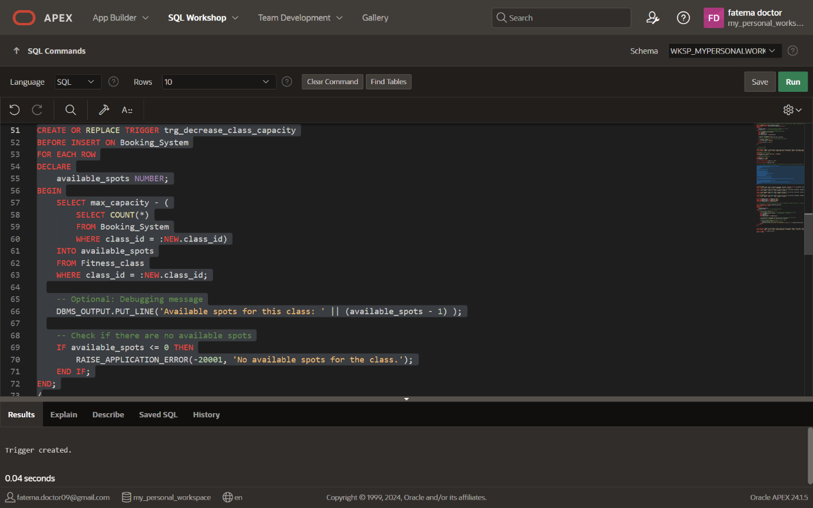

*Fig 8.7 Creating 2nd Trigger*

*Testing the trigger*

INSERT INTO Fitness_class (class_id, staff_id, class_name, class_type, class_time, duration, max_capacity, class_status)

VALUES ('TEST1', 'ST014', 'Yoga', 'Fitness', SYSTIMESTAMP, '1 Hour', 2, 'Active');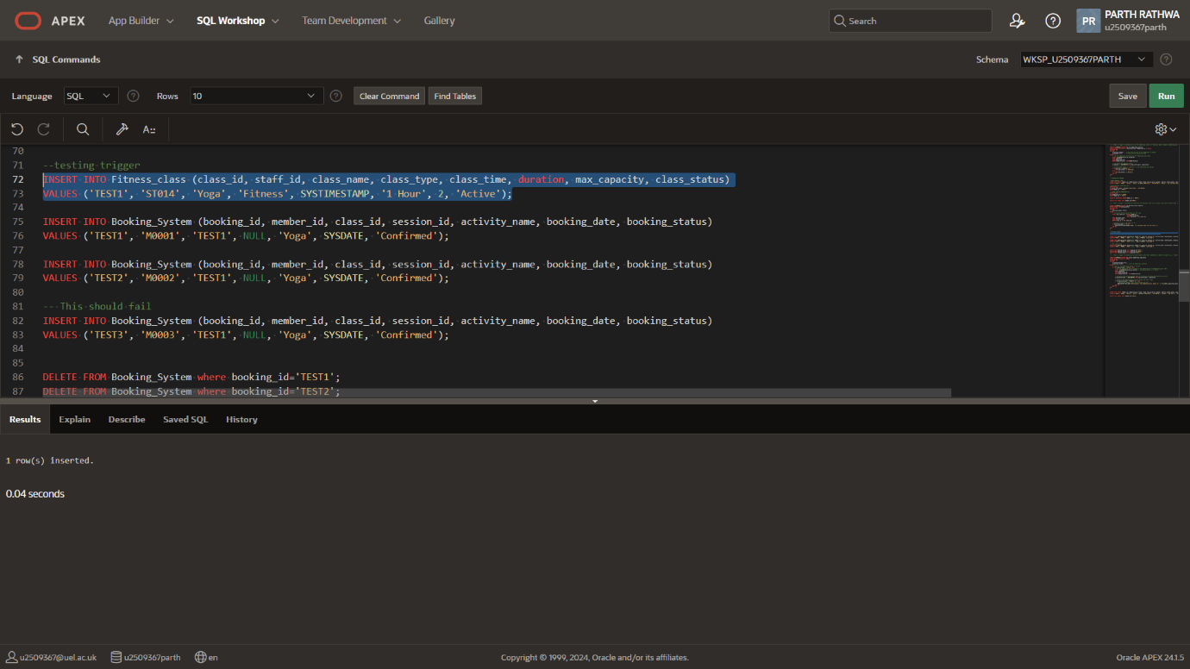

*Fig 8.8 Trigger 2: Inserting the data*

INSERT INTO Booking_System (booking_id, member_id, class_id, session_id, activity_name, booking_date, booking_status)

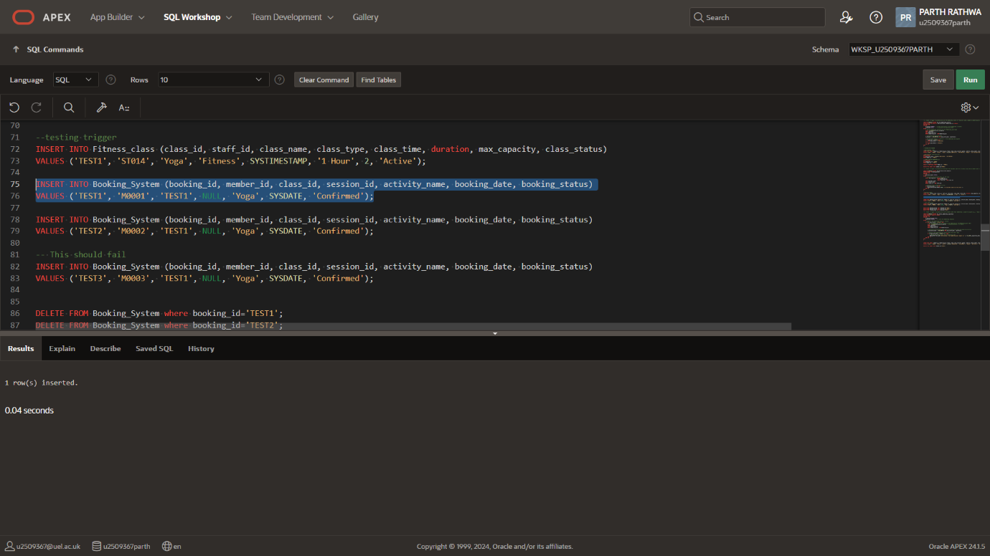VALUES (‘TEST1’, ‘M0001’, ‘TEST1’, NULL, ‘Yoga’, SYSDATE, ‘Confirmed’);

*Fig 8.9 Trigger 2: Inserting the data*

INSERT INTO Booking_System (booking_id, member_id, class_id, session_id, activity_name, booking_date, booking_status)

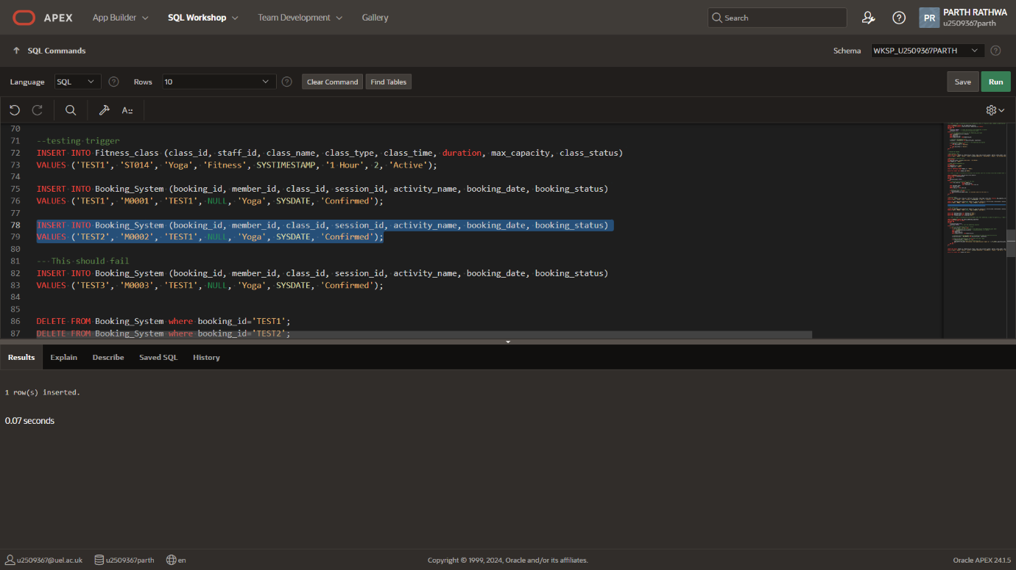VALUES (‘TEST2’, ‘M0002’, ‘TEST1’, NULL, ‘Yoga’, SYSDATE, ‘Confirmed’);

*Fig 8.10 Trigger 2: Inserting the data*

INSERT INTO Booking_System (booking_id, member_id, class_id, session_id, activity_name, booking_date, booking_status)

VALUES ('TEST3', 'M0003', 'TEST1', NULL, 'Yoga', SYSDATE, 'Confirmed');

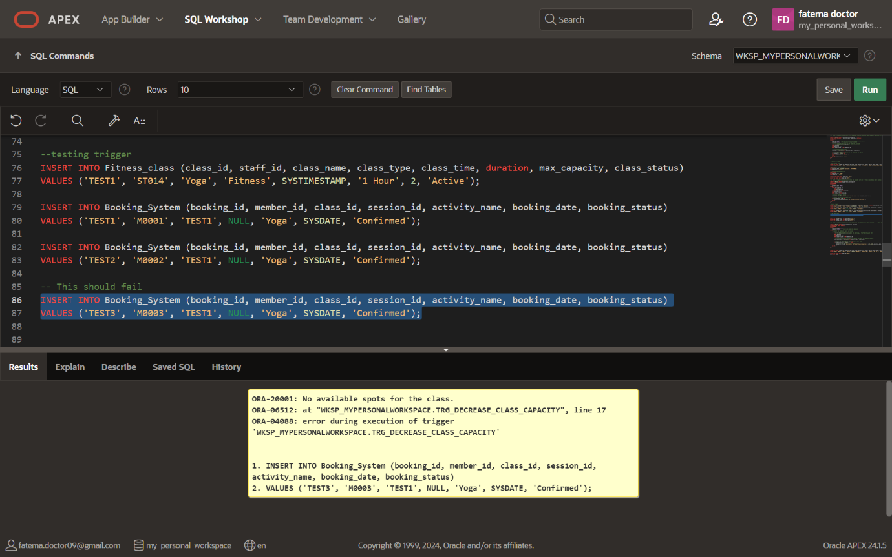

*Fig 8.11 Trigger 2: Cannot insert the data*

## *Trigger 3:*

**Notify members 7 days before their membership expires.**

CREATE OR REPLACE TRIGGER trg_notify_membership_expiration

AFTER INSERT OR UPDATE ON Member

FOR EACH ROW

DECLARE

v_expiration_date DATE;

v_duration NUMBER;

-- To store the membership duration

BEGIN

-- Check if the membership status is 'Active'

IF :NEW.plan_status = 'Active' THEN

-- Get the membership duration based on the membership_id from Membership_plan table

SELECT TO_NUMBER(duration_in_months)

-- Assuming duration is in months

INTO v_duration

FROM Membership_plan

WHERE membership_id = :NEW.Membership_id;

-- Calculate the expiration date based on the plan_start_date and membership duration

v_expiration_date := ADD_MONTHS(:NEW.plan_start_date, v_duration);

-- Check if the membership will expire within the next 7 days

IF v_expiration_date - SYSDATE <= 7 THEN

-- Notify the member (e.g., print message for now)

DBMS_OUTPUT.PUT_LINE('Notification: Your membership will expire on ' || TO_CHAR(v_expiration_date, 'DD-MON-YYYY') || '. Please renew your membership.');

END IF;

END IF;

END;

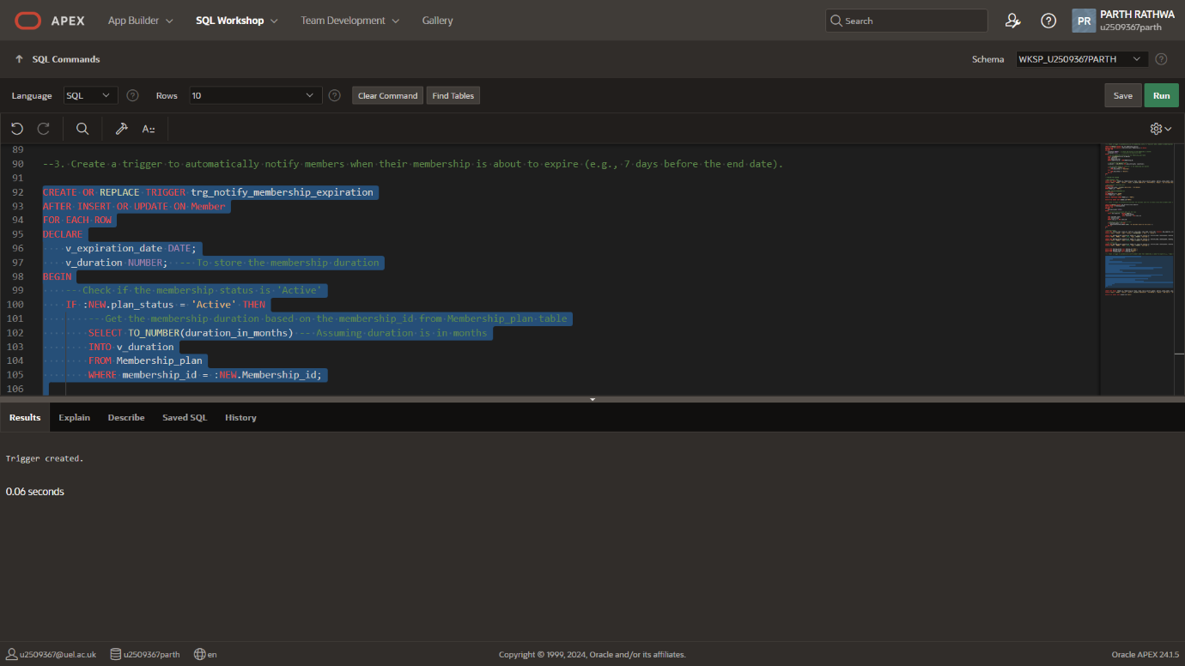/

*Fig 8.12 Creating the trigger*

INSERT INTO Member (Member_id, Membership_id, Fname, lname, date_of_birth, gender, address, phone_number, email, emergency_contact, plan_start_date, plan_status)

VALUES ('TEST1', 'MS001', 'Monica', 'Geller', TO_DATE('1995-05-20', 'YYYY-MM-DD'), 'Female', '456 Elm St', '555-6789', 'monica.geller@example.com', '555-1234', TO_DATE('2024-09-15', 'YYYY-MM-DD'), 'Active');

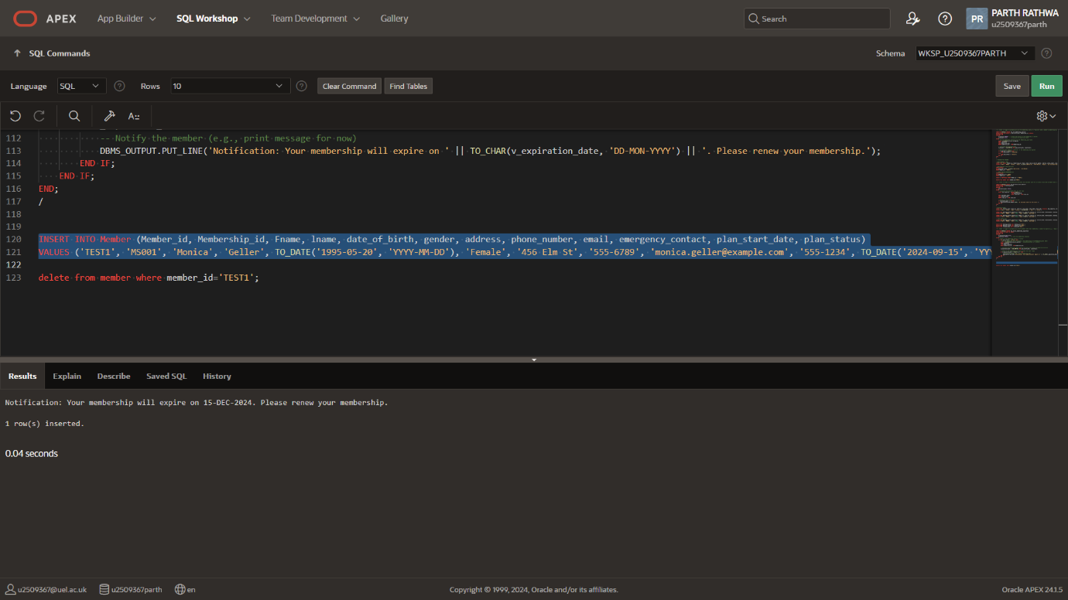

*Fig 8.13 Inserting data to test trigger 3*

# 

# **9. Report Reflection**

## **9.1. Challenges, Key Learnings, and Improvements (CKI)**

#### **Challenges Faced**

* Complex database design, especially in normalizing relationships between members, staff, and classes.
* Implementing triggers and stored procedures required careful testing to ensure proper automation.
* Optimizing SQL queries for large datasets and complex joins was challenging.

#### **Key Learnings**

* Gained experience in designing and normalizing relational databases.
* Improved skills in writing SQL queries, triggers, and stored procedures for database management.
* Learned the importance of teamwork, collaboration, and problem-solving.

#### **Improvements**

* A more user-friendly interface would enhance accessibility.
* Integrating a mobile app could simplify class bookings and member tracking.
* Advanced reporting features could provide deeper insights for gym management.
* AI integration could improve member engagement and operational efficiency.

## **9.2 Group Contribution Evaluation:**

|  |  |  |  |  |
| --- | --- | --- | --- | --- |
| Group Work: Self and Peer Evaluation | | | | |
| Each group member's performance based on the following Scale: | | | | |
| *3 = All/most of the time; 2 = Sometimes/Occasionally; 1 = Rarely/Never* | | | | |
| *Student ID* | ***2571395*** | ***2604383*** | ***2509367*** | ***2393577*** |
| A. Participated in Discussion | 3 | 3 | 3 | 3 |
| B. Maintained a Positive Attitude | 3 | 3 | 3 | 3 |
| C. Contributed to the work | 3 | 3 | 3 | 3 |
| D. Stayed on task | 3 | 3 | 3 | 3 |

*Table 9.1 Group work evaluation*

# 

# **10. Gantt Chart**

* Our Gantt chart showing the project timeline:
  + Tasks: ERD design, normalization, DDL scripts, SQL queries, testing, documentation, etc.
  + Timeline: Weeks or milestones to track progress.



*Fig. 10.1 Gantt chart*

# 

# **11. Appendices**

## *PowerPoint Slides:*

|  |  |
| --- | --- |
|  |  |
|  |  |
|  |  |
|  |  |
| Inserting image... |  |

## *SQL Scripts:*







# **Additional Notes**

* **Tools**:
  + Oracle Data Modeler
  + <https://apex.oracle.com>
  + <https://draw.io/>